

**Molecular Modelling of Covalent Inhibition of Bruton’s Tyrosine Kinase by Cyanoacrylamides**

Jonathan Yik Chang Ting

*A Research Report submitted for the degree of Bachelor of Advanced Science (Honours) at*

*The University of Queensland in October 2019*

School of Chemistry & Molecular Biosciences

**Declaration by author**

This research report is composed of my original work, and contains no material previously published or written by another person except where due reference has been made in the text. I have clearly stated the contribution by others to jointly-authored works that I have included in my report.

I have clearly stated the contribution of others to my research report as a whole, including statistical assistance, survey design, data analysis, significant technical procedures, professional editorial advice, and any other original research work used or reported in my report. The content of my report is the result of work I have carried out since the commencement of my honours research project and does not include a substantial part of work that has been submitted to qualify for the award of any other degree or diploma in any university or other tertiary institution. I have clearly stated which parts of my research report, if any, have been submitted to qualify for another award.

I acknowledge that copyright of all material contained in my research report resides with the copyright holder(s) of that material.

**Statement of Contributions to Jointly Authored Works Contained in the Research Report**

No jointly-authored works.

**Statement of Contributions by Others to the Research Report as a Whole**

*Elizabeth Krenske:*

Elizabeth is a major steerer of the research direction of the project. She had pointed the author toward relevant literature and patiently explained the reasons behind certain common practices in the field. She had constantly provided suggestions of research direction and posed interesting questions to be answered. She critically reviewed the work and asked complementary questions to provide a fuller picture of the results obtained. She contributed significantly to the analysis and interpretation of the results, especially on the quantum mechanical data calculated.

*Alan Mark:*

Alan shared his expertise on the parameterisation of classical force fields and the effects of parameter choices such as implicit solvent model on the computed energies. He critically reviewed the work and assisted in the interpretation of the results. He also provided useful suggestions to make the work more concise and coherent. His permission to store the massive amount of data generated from the simulations on the hardware of his group allowed the analysis to be conducted easier.

*Thomas Lee:*

Thomas provided help to truncate the excessive amino acids from the non-standard amino acids built on the ATB web server and shared his expertise on molecular dynamics simulations using AMBER programs on the GPU-accelerated high-performance cluster at UQ. He had made his codes of conversion of GROMOS topologies into AMBER-compatible formats available on the ATB. He has also addressed the questions raised and technical issues found throughout the preparation of the simulation systems and analysis of the results.

*Martin Stroet:*

Martin had provided access for parameterisation of the inhibitors and non-standard amino acids built on the ATB web server at higher level of theory. His warnings against the potential pitfalls of inappropriate parametrisation of the non-standard amino acids are greatly appreciated. He has also provided guidance in the analysis of the molecular dynamics simulations results, putting a lot of emphasis on finding what is real and asking objective questions. His knowledge on the strengths and limitations of GROMOS force field had been of immense help to the project.

*Yuk Ping Chin:*

Yuk Ping introduced convenient ways for conversion of molecular coordinate file formats and provided tutorial for some functionalities of GaussView, MacroModel and NCIPLOT softwares. She had also shared her expertise in high-performance clusters navigation and circumventing issues that lead to premature termination of quantum mechanical calculations.

*Romain Lepage:*

Romain provided useful suggestions to aid in the location of some transition state structures. He also aided the author in making informed choices on the selection of parameters for quantum mechanical calculations using Gaussian16 and understanding basic concepts on the algorithms used for the calculations.

*David Poger:*

David provided critical advice regarding the construction of residues missing in the X-ray crystal structures of the proteins used in the simulations and helped with the specification of the simulation parameters used in the molecular dynamics studies of proteins under biological condition.

This research was supported by a University of Queensland School of Chemistry and Molecular Biosciences Honours Scholarship.

**Statement of Parts of the Research Report or Submitted to Qualify for the Award of Another**

**Degree**

None.

**Published Works by the Author Incorporated into the Research**

None.

**Additional Published Works by the Author Relevant to the Research Report or but not Forming Part of it**

None

**Acknowledgements**

I thank Associate Professor Elizabeth Krenske and Professor Alan Mark for the supervisions throughout the year. I also wish to thank Dr. Martin Stroet and Dr. Thomas Lee for their patience in answering my questions and guidance provided in molecular dynamics simulations on Wiener, providence of codes that enables the setup of systems containing non-standard amino acids, simulation of GROMOS systems using graphics processing unit-accelerated AMBER machineries, and the analysis of the results. I am grateful to Jack Taunton and his colleagues for making the co-crystal structure of BTK with inhibitor molecule 3 from their experimental work publicly available. I thank my other colleagues in both laboratories for making my Honours research experience such interesting and exciting. Computer resources provided by the National Facility of the National Computational Infrastructure (Australia) through the National Computational Merit Allocation Scheme and by the University of Queensland Research Computing Centre are greatly appreciated. I am grateful for the financial support given by the School of Chemistry and Molecular Biosciences through the Honours scholarship.

**Signature of Author: _____________________________ Date: ____________**

**Principal Supervisor Agreement**

I have read the final report and agree with the student’s declaration.

**Signature of Principal Supervisor: ______________________________Date: _________**

ABSTRACT

The abstract should outline the main approach and findings of the thesis and must be between 300 and 800 words.

TABLE OF CONTENTS

ABSTRACT vii

TABLE OF CONTENTS viii

LIST OF ABBREVIATIONS xi

1 INTRODUCTION 1

1.1 Background and Significance 1

1.1.1 Covalent Drugs. 1

1.1.2 Residence Time and its Relationship to Pharmacological Effects. 3

1.1.3 Discovery of Reversible Covalent Inhibitors of Bruton’s Tyrosine Kinase. 4

1.1.4 Questions Emerging from Previous Work. 8

1.1.5 Previous Computational Studies of BTK. 10

1.2 Objectives 11

2 QUANTUM CHEMICAL CHARACTERISATION OF THE INTRINSIC REACTIVITIES OF COVALENT INHIBITORS. 12

2.1 Methods 12

2.1.1 Choice of Michael Acceptors 12

2.1.2 Properties of Interest 13

2.1.3 Conformational Sampling 14

2.1.4 Factors Influencing Choice of QM Methods 15

2.1.5 Calculation of Gibbs Free Energy 16

2.2 Results and Discussion 19

2.2.1 Conformational Analysis of Critical Point Species along the Reaction Coordinates 19

2.2.2 Benchmarking of Functionals and Basis Sets for Thiol Additions to Cyanoacrylamides 23

2.2.3 Calculations of Thermodynamic Quantities of Thiol-Michael Additions of MeSH to the Acrylamide Inhibitors 24

2.2.4 Rationalisation of the Calculated Thiol-Michael Addition Barrier 28

3 INVESTIGATIONS OF THE BINDING OF COVALENT INHIBITORS TO BTK 34

3.1 Methods 34

3.1.1 General Aspects 34

3.1.2 Preparation of the System 34

3.1.3 Setup for MD Simulation 36

3.1.4 Trajectory Analysis 36

3.2 Results and Discussions 38

3.2.1 Identification of the Potential Base Catalyst 38

3.2.2 Conformational Changes that Occur Upon Binding of Cyanoacrylamides 1 and 3 to BTK 44

3.2.3 Trajectory Analysis of BTK Noncovalently Bound to Different Acrylamide Inhibitors 46

4 CONCLUSIONS AND FUTURE DIRECTIONS 50

4.1 Conclusions 50

4.2 QM/MM Studies 51

4.2.1 Location of TS Structures 52

4.2.2 Selectivity of Inhibitor 9 for BTK 52

5 REFERENCES 54

6 APPENDIX 63

6.1 Details of QM Parameters Used 63

6.2 Benchmarking of Force Fields for Conformational Sampling 63

6.3 Failure of MacroModel to Locate Stable s-*cis* Conformer 64

6.4 Comparison of QM Calculated Most Stable Geometry with the Structure of Inhibitors 3 Covalently Bound to BTK 66

6.5 Omitted Data from Benchmarking of QM Methods 67

6.6 Identification of the Most Relevant HOMO for Electrophilicity Index Computation 68

6.7 Formation of van der Waals Complex Prior to Transition States 69

6.8 Plots of Correlation between Other Charge Schemes and Calculated Addition Barriers 70

6.9 Details of MD Parameters Used 71

6.9.1 Preparation of GROMOS System 71

6.9.2 Simulation of AMBER System 72

6.10 Plotted Figures from Distance Analyses 73

6.10.1 Potential Base for Thiol Additions 73

6.10.2 Potential Base for Thiol Eliminations 75

6.11 Energy Barriers for Different Thiol Elimination Mechanisms 77

6.12 Programming Scripts Written 78

6.12.1 Gaussian Job Generation and Submission 78

6.12.2 Management and Modification of Files and Directories 78

6.12.3 Post-Calculation Correction, Tabulation, and Visualisation of QM Calculation Results 79

6.12.4 Automated Analysis of MD Trajectories 79

6.12.5 Preparation of MD Systems and Visualisation of MD Trajectory Analysis Results 79

LIST OF ABBREVIATIONS

|  |  |
| --- | --- |
| **AMBER** | Assisted Model Building with Energy Refinement |
| **Arg** | Arginine |
| **ATB** | Automated Topology Builder |
| **BTK** | Bruton’s Tyrosine Kinase |
| **CM5** | Charge Model 5 |
| **CPCM** | Conductor-like Polarisable Continuum Model |
| **CPU** | Central Processing Unit |
| **Cys** | Cysteine |
| **DFT** | Density Functional Theory |
| **EA** | Electron Affinity |
| **ESP** | ElectroStatic Potential |
| **GBSA** | Generalised Born model augmented with the hydrophobic solvent accessible Surface Area |
| **GGA** | Generalised Gradient Approximation |
| **GROMOS** | GROningen MOlecular Simulation |
| **HF** | Hartree-Fock |
| **HOMO** | Highest Occupied Molecular Orbitals |
| **HSAB** | Hard-Soft Acid-Base |
| **IP** | Ionisation Potential |
| **LUMO** | Lowest Unoccupied Molecular Orbitals |
| **MA** | Michael Acceptor |
| **MAD** | Mean Absolute Deviation |
| **MD** | Molecular Dynamics |
| **MM** | Molecular Mechanics |
| **MTLMS** | Mixed Torsional/Low-Mode Sampling |
| **NBO** | Natural Bond Orbital |
| **NCI** | NonCovalent Interaction |
| **OPLS** | Optimized Potentials for Liquid Simulations |
| **PBC** | Periodic Boundary Conditions |
| **PDB** | Protein Data Bank |
| **PES** | Potential Energy Surface |
| **PME** | Particle Mesh Ewald |
| **QM** | Quantum Mechanics |
| **QSAR** | Quantitative Structure-Activity Relationship |
| **QTAIM** | Quantum Theory of Atoms in Molecules |
| **RDS** | Rate Determining Step |
| **RMSD** | Root-Mean-Square Deviation |
| **RT** | Residence Time |
| **SAR** | Structure-Affinity Relationships |
| **SKR** | Structure-Kinetic Relationships |
| **SPC** | Simple Point-Charge |
| **SPE** | Single Point Energy |
| **TS** | Transition State |
| **vdW** | van der Waals |
| **VMD** | Visual Molecular Dynamics |

# INTRODUCTION

## Background and Significance

### Covalent Drugs.

The ability of a small molecule, such as an inhibitor, to modify the activity of a target enzyme is largely dependent on the strength of the interaction formed between the molecule and the enzyme. Covalent inhibitors are molecules that inhibit their target proteins by forming covalent attachments to them.1 They complement conventional (noncovalent) inhibitors by enabling the achievement of much higher binding affinities to their targets.2 Such capability opens up the possibility for lower drug dosage and dose frequencies in the treatment of disease, potentially allowing covalent drugs to have safety profiles, provided that an acceptable target selectivity is achieved.3

The structures of several common covalent drugs are shown in Figure 1.1. As illustrated by these examples, covalent inhibitors typically bear a reactive electrophilic functional group, called a warhead, which forms a covalent bond with a nucleophilic residue,4 such as cysteines, serines, and threonines, at the target site. Noncovalent interactions with the target protein enables proper positioning of the molecule and also contributes to the overall binding interaction. The selectivity of inhibition can be enhanced by targeting noncatalytic residues,5 which often varies across different enzymes.3,6 One important class of warheads used in covalent drugs are α,β-unsaturated carbonyl compounds, also known as Michael acceptors (MAs). The mechanism of action of a MA as a covalent drug involves conjugate addition and is exemplified in Scheme 1 with methanethiol being the nucleophile. Once the inhibitor enters the binding site, a deprotonated cysteine thiol group adds to the $β$ position of the MA. This forms an enolate intermediate which is then protonated to form the corresponding thiol adduct. For both thiol addition and elimination, a base species acts as a catalyst by deprotonating the thiol or adduct.



**Figure 1.1.** Structures of several well-known covalent inhibitors. The bond-forming functional groups are highlighted in red.

Scheme 1.1. General Reaction Scheme for Thiol Addition to a Michael acceptor.



Despite the advantages of well-known covalent inhibitors such as aspirin,7 penicillin,8 and fosfomycin,9 few covalent drugs were designed deliberately to act as covalent inhibitors, due to the risk of side effects.3 The formation of covalent bonds often, albeit not always, corresponds to an equilibrium lying far towards the covalent adduct, leading to essentially irreversible enzyme modification, which has risks including severe idiosyncratic drug reactions such as toxic epidermal necrolysis,10,11 drug-induced liver injury,12,13 and multiple haematological disorders.14 Reversible inhibitors are normally favoured over irreversible ones in drug design as they are less likely to form permanent adducts with off-target proteins containing homologous or highly-reactive residues.15-17 Furthermore, reversible inhibition also allows fine tuning of a critical parameter known as the drug-target residence time (RT), ,18 the importance of which has emerged over the last decade. RT is defined as the reciprocal of the off-rate constant $k_{off}$, as shown in equation (1). This feature allows for tailoring of the duration of the effect of a reversible drug by varying RT.

|  |  |  |
| --- | --- | --- |
| $$τ=1/k_{off}$$ |  | (1) |

### Residence Time and its Relationship to Pharmacological Effects.

Traditionally, the optimisation of drug-target interactions has been determined by the equilibrium-derived binding parameters, such as the equilibrium dissociation constant, $K_{d}$ and the half-maximal inhibitory concentration, IC50.18 However, unlike *in vitro* experiments, the dynamic blood flow *in vivo* induces fluctuations in the concentration of unbound inhibitors over time. This prevents the system from arriving at equilibrium and thus renders the physiological environment an open system.19,20 Due to the fundamental differences between open and closed systems, binding kinetic parameters, especially RT, have grown in importance as optimisation measures for drug candidates alongside binding affinity and potency.18-24 Considering the fact that the efficacy of a drug originates from its interaction with its physiological target, a strong correlation between the length of time a drug remains bound to its target and its clinical efficacy is expected.18,19,23 For example, Swinney reported that therapeutics with long RTs demonstrated good clinical efficacy and potentially involved non-equilibrium conditions in their mechanism of action.25 However, it should be emphasised that a long RT is not always required or desired. While sustained target engagement is required for the treatment of cancers,22 allergies,22 hypertension,26 and hormone-dependent diseases,27 proteins that undergo fast turnover through resynthesis do not benefit much from the prolonged duration of action of long RT drugs. Besides, these inhibitors are unsuited for therapeutic applications where rapid dissociation is preferred,22,28 such as thrombosis18,29 and antipsychosis.19 In fact, long RTs may even be a contradiction for these clinical indications due to the convolution of the effect of drug occupancy at the same site on both efficacy and toxicity.22 As such, the ability to tune the drug-target RT has been a major focus within the covalent drug discovery community.

### Discovery of Reversible Covalent Inhibitors of Bruton’s Tyrosine Kinase.

In order to counteract the abovementioned dangers of irreversible binding of covalent inhibitors to enzymes, new classes of covalent inhibitors that engage their targets reversibly have been designed. In this context, Taunton et al. reported an important discovery by designing reversible covalent inhibitors that targeted noncatalytic cysteine residues in Bruton’s Tyrosine Kinase (BTK).5 BTK is a member of the Tec tyrosine kinase family which participates in immune function regulation through B-cell development.30,31 Its inhibition has been utilised for treatment of various cancers32,33 and autoimmune diseases.34,35 Ibrutinib36 (Figure 1.2) was the first BTK inhibitor approved by the US Food and Drug Administration as a medicament for chronic lymphocytic leukaemia,32 and is also used to treat mantle cell lymphoma33 as a second-line treatment.37 Ibrutinib consists of a kinase-recognition scaffold (blue) linked to an acrylamide warhead (red) that is capable of forming covalent bonds with appropriate nucleophiles.



**Figure 1.2.** Structures of ibrutinib and acalabrutinib. The MA moieties and the kinase-recognition scaffolds are highlighted in red and blue, respectively.

However, ibrutinib does not have optimal selectivity. It led to permanent inhibition of analogous kinase targets35,38 such as epidermal growth factor receptor, interleukin-2-inducible T-cell kinase and T-cell X chromosome kinase, causing severe adverse events including atrial fibrillation, major haemorrhage, and arthralgia.33,39 To date, acalabrutinib40 is the only other approved inhibitor of BTK. Even though it exhibits better kinase selectivity compared to ibrutinib,41,42 the irreversible nature of its binding interaction42 naturally triggers concerns regarding its as-yet unknown off-target effects. This is especially important for the treatment of autoimmune diseases, which typically requires frequent application.43 Accordingly, this prompted the exploration of reversible inhibition of BTK as an alternative solution.

The inhibitor molecules investigated by Taunton et al. resembled ibrutinib except that cyanoacrylamides were used in place of acrylamides as warheads. This modification was based on observations made in earlier chemical experiments, where the installation of the nitrile groups at the $α$ position of acrylamides resulted in rapidly reversible Michael additions.6 Quantum mechanical (QM) calculations revealed that the reversibility arises because the electron-withdrawing $α$-CN substituent both stabilises the anionic transition state (TS) and destabilises the neutral adduct, thus decreasing the change in free energy, $ΔG$ for binding and accelerating the reverse reaction (elimination of thiol) as illustrated in Figure 1.3.44



**Figure 1.3.** Representative $ΔG$ profiles for irreversible and reversible Michael additions.

By varying the electronic and steric environment around the warhead by using different $β$-substituents on the cyanoacrylamides, Taunton et al. developed inhibitors exhibiting RT ranging from just minutes to one week. Key examples are presented in Chart 1.1. Significantly, long RT was found to translate into durable *in vivo* pharmacodynamic inhibition, where the longest-lived inhibitor, **9**,demonstrated sustained BTK occupancy even after clearance of unbound drugs from the systemic circulation in rodent models. In a recent review article, Copeland45 commented that the achievements of Taunton’s group unlocked the possibility of systematically approaching the holy grail of covalent inhibitor design, i.e. addressing the requirement to specifically inhibit certain proteins to treat targeted diseases through rational tuning of the structural features of the inhibitors and their binding interactions. Following Taunton’s pioneering work, the incorporation of structure-kinetic relationships (SKR), distinct from the traditional structure-affinity relationships (SAR), into cell-based assays has been encouraged owing to the increasing awareness of the importance of binding kinetics in drug discovery.24,45-56 Many research groups have followed up on these ideas to advance the exploration of kinase inhibition by covalent means.57-66

Chart 1.1. Structures and Binding Data of Reversible Covalent Inhibitors of BTK Designed by Taunton et al.5



*a***4** and **5** have R linker configurations instead of S. *b***5** contains an acrylamide electrophile instead of cyanoacrylamide. *c***6** does not contain a MA and is included for comparison.

### Questions Emerging from Previous Work.

It is unclear is how the different structural components of cyanoacrylamides govern the reversibility of their binding to kinases such as BTK. The overall reversibility of binding depends on a combination of multiple effects, including the overall $ΔG$ for the addition and the rate constants for binding and release. These properties are also fundamentally important to the selectivity of an acrylamide across different kinases. For example, **9** has also been found to show exceptional selectivity for BTK over other kinases, yet the molecular basis for the selectivity is yet to be uncovered.

In a computational study, Taunton et al. discovered67 an inverse correlation between the $β$-elimination rates of thiol adducts and the proton affinities of the intermediate enolate carbanions. This suggested that it may be possible to use computed proton affinities to predictably tune the intrinsic reversibility of acrylamide thiol additions. In spite of this, examination of the experimental data in Chart 1, especially the comparison between the RT of diastereomers **4** and **7**, reveals that acidity is not the only important criterion that determines the $β$-elimination rates; other factors such as steric hindrance, the impact of substituents on the overall electrophilicity, and, importantly, interactions with the BTK binding site, must also contribute to determining the overall behaviour of a given acrylamide. Unravelling the factors that determine the RT of acrylamide inhibitors is expected to be useful for understanding not only BTK inhibition but also for designing inhibitors of related cysteine-containing enzymes and predicting the selectivity of a given inhibitor against a range of kinases.

Prior to their computational work, Taunton’s group had already proposed several other hypotheses to explain the observed trends of drug-target RT based on the examination of a co-crystal structure of BTK, with its Cys481 covalently bonded to **3** as depicted in Figure 1.4. They identified two hydrophobic patches in the vicinity of the *tert*-butyl group of **3** and claimed that the hydrophobic interactions contributed to the stabilisation of the covalent adduct. The alignment between the C=O $π$ bond and the C $α$-H bond was not perpendicular, which led Taunton et al. to propose that the acidity of the hydrogen was lowered, both thermodynamically and kinetically.5 Furthermore, it was suggested that the C $α$ hydrogen, which needs to be removed as the first step of thiol elimination, was shielded from potential base species as a result of the orientation of the capping group and piperidine amide to minimise torsional strains and steric clashes. However, the base catalyst was unidentified. If the base is in fact an external one, the solvent-exposed Cα hydrogen would be readily accessible to it, leaving the argument of Taunton et al. on shaky ground.

It should be noted that X-ray structures merely present an average, static representation of what is really a dynamic, structurally diverse ensemble in the crystal.68,69 This limitation means that the X-ray structure should be interpreted with some caution and other measures should be employed to better understand the protein dynamics.70,71 Simulations at an atomistic level would accomplish this goal.

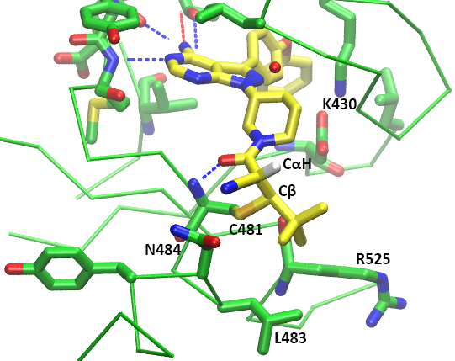

**Figure 1.4.** Crystal structure of BTK bound to the reversible covalent inhibitor **3** (2.2 Å resolution).5 The covalent bond between Cβ and Cys481, the acidic Cα hydrogen, and the hydrogen bonds that possibly contribute to stabilising the covalent adduct are indicated.

### Previous Computational Studies of BTK.

Numerous computational studies have been performed on BTK, in many cases using molecular dynamics (MD) simulations. For instance, a combination of MD simulations and 3D quantitative structure-activity relationship (QSAR) models have been used to screen noncovalent BTK inhibitors based on binding affinities.72-76 Related MD studies have helped to improve the understanding of the biological functions of different domains of BTK,77,78 the features involved in BTK changing from an inactive to an active state79 and the interactions of BTK with its natural substrates, phosphatidylinositols.78,80 To date, only a single study associated with BTK has utilised QM calculations.72 That work employed density functional theory (DFT) to calculate the electronic excitation energy of BTK-targeting inhibitors. The functional and basis set combination chosen for the geometry optimisations of the detected hits was the B3LYP/6-31G*, which is notorious for its poor treatment of London dispersion.81,82 Fortunately, this suboptimal choice was somewhat attenuated by the fact that the study only focused on the structures of the inhibitors and not their thiol adducts, thus avoiding problems associated with spurious charge-transfer complexes. The limitations of the standard DFT methods in the modelling of thiol additions will be discussed further in the following methodology section. Taken together, however, the body of computational work reported thus far illustrates the many possibilities for gaining atomistic insight into BTK inhibition using appropriate computational tools.

## Objectives

The ultimate goal of the present work is to elucidate the factors that affect the kinetics and thermodynamics of thiol additions in the context of the binding of cyanoacrylamide-containing MAs to Cys481 of BTK. The intention is to perform the first ever study of BTK binding site environmental effects on the reactivities of these inhibitor molecules. It is hoped that a deeper understanding of the binding interactions will enable more rational design of BTK inhibitors in the future. Such an understanding could also facilitate the design of reversible covalent inhibitors for other kinases.

In this project, these goals were approached in the following way:

* performing QM calculations to determine the intrinsic reactivities of different cyanoacrylamide warheads towards a model thiol, and
* conducting MD studies to explore the impact of residues near BTK active site on the binding of the inhibitors.

Given the importance of the tunability of *in vivo* RT, the results of these computations are anticipated to contribute to the advancement of the still maturing field of protein kinase covalent inhibitor discovery.48,83,84

# QUANTUM CHEMICAL CHARACTERISATION OF THE INTRINSIC REACTIVITIES OF COVALENT INHIBITORS.

The following chapter aims to study the intrinsic reactivities of the acrylamide inhibitors investigated by Taunton through QM calculations. The topics covered include conformational analysis of the relevant species, benchmarking of QM methods against similar compounds, calculation of thermodynamic and kinetic parameters using the chosen method, and investigation on the correlations between some molecular properties and the calculated addition barriers.

## Methods

### Choice of Michael Acceptors

From Taunton’s set of inhibitors, six examples were selected for detailed study to reveal how structural factors determine the intrinsic reactivities of acrylamide warheads (Figure 2.1).



**Figure 2.1.** The acrylamide inhibitors chosen for detailed study.

First, acrylamide **3** was chosen due to the availability of its co-crystal structure with BTK. The related acrylamide **1**, with a methyl group in place of the *tert*-butylof **3**,was chosen to compare with **3**. The pair of diastereomers **4** and **7** were next chosen, to explore the effect of the different configurations of the stereogenic centre in the linkers. Inhibitor **9** was chosen as it displayed the longest RT out of those studied by Taunton. Finally, the acrylamide **5**, lacking a cyano group, was included as a control, as it exhibited irreversible BTK inhibition. As the computational expenses grow exponentially with increasing number of electrons, the scaffolds of the inhibitors were truncated to piperidine groups. Their effects on the intrinsic reactivity are likely to be minimal, due to their remoteness from the electrophilic centre. The truncated inhibitors will be differentiated from the original molecule by adding the prefix **R** to the compound number, e.g. **R3** is the model for **3**. As a special case, the truncated forms of **4** and **7** are identical and are labelled **R4(7)**. The thiol was modelled as methanethiol (MeSH) for the sake of simplicity.

### Properties of Interest

The application of statistical mechanics to QM systems allows the derivation of thermodynamic quantities including Gibbs free energy, $G$ from the partition functions.85 The activation free energy barrier ($ΔG^{‡}$) and free energy change ($ΔG$) for the addition of a thiol to a MA (or the reverse reaction, elimination) can therefore be estimated from QM calculations on reactants, TS and products. The rate constant for thiol elimination (off-rate), $k_{off}$, can be computed using equation (2), the Eyring equation:86

|  |  |  |
| --- | --- | --- |
|  |  | (2) |

where $κ$ is a transmission coefficient, which reflects the fraction of the molecules overcoming the activation barrier that proceeds to the product without recrossing the TS, $k_{B}$ is Boltzmann’s constant, $T$ is absolute temperature, $h$ is Planck’s constant, $ΔG_{reverse}^{‡}$ is the elimination activation barrier calculated by DFT, and $R$ is gas constant, respectively. Assuming that the no-recrossing assumption of the TS theory86 is held, a value of 1 is typically assigned to $κ$. The calculated results can be compared with the experimentally measured half-life, $t_{1/2}$, which is related to $k_{off}$ by a factor of $ln⁡(2)$ for first order reactions as shown in equation (3):

|  |  |  |
| --- | --- | --- |
| $$t_{1/2}=τln⁡(2)$$ |  | (3) |

The $ΔG$, $ΔG^{‡}$, $k_{off}$ and $t_{1/2}$ values were calculated for thiol additions to Taunton’s cyanoacrylamide warheads (Figure 2.1).

### Conformational Sampling

The reactivity of a molecule is highly dependent on its geometry. Since molecules at any temperature constantly undergo changes in their molecular geometries, e.g. through vibrations, measured properties are an average over the ensemble of all possible states. The properties are predominantly determined by the lowest energy conformers as the conformational population follows a Boltzmann distribution as shown in equation (4):

|  |  |  |
| --- | --- | --- |
| $$\frac{N_{i}}{N_{total}}=\frac{e^{-E_{i}/RT}}{\sum_{k=1}^{M}{e^{-E_{k}/RT}}}$$ |  | (4) |

where $N_{i}$ is the expected number of particles in the single-particle microstate $i$, $N_{total}$ is the total number of particles in the system, $E_{i}$ is the energy of microstate $i$, $R$ is gas constant, $T$ is the equilibrium temperature of the system, and $M$ is the total number of microstates. As such, the most important conformers for the key species involved in a reaction, namely reactants, TS structures and products, need to be identified prior to the calculation of the thermodynamic parameters.

The conformational searching essential to the identification of the ground state conformers was guided by molecular mechanics (MM) to enable efficient exploration of the large conformational space. This was done for each species using mixed torsional/low-mode sampling (MTLMS) method in the MacroModel software,87 which has been demonstrated to be an effective sampling method for flexible compounds.88 For thiol adducts, all possible diastereomers were constructed and the lowest energy diastereomer was used for analysis. For TSs, *syn* (C-S-C=C dihedral angle < 90º) and *anti* (C-S-C=C dihedral angle > 90º) conformations for thiolate attack on both *Re* and *Si* faces of the MA were calculated. The structures were then QM optimised and used as the input geometry for the conformational sampling.

The molecular interactions were described using the (Optimized Potentials for Liquid Simulations Version 3 Extended) OPLS3e force field.89 Benchmarking of other force fields was also conducted and is discussed in the Appendix 6.2.1. The first 15 conformers with a mean absolute deviation (MAD) of at least 0.5 Å from previously located energy minima within an energy window of 3 kcal/mol were stored from a sampling of 1000 maximum steps and 100 steps per rotatable bond. The implicit Generalised Born model augmented with the hydrophobic solvent accessible surface area (GBSA) was employed to simulate infinitely diluted aqueous solution. The S-C bonds to be formed in TS were constrained during the samplings.

### Factors Influencing Choice of QM Methods

Historically, the first computational studies of thiol-Michael additions using *ab initio* methods were performed by Kollman et al. in 1995.90 Subsequently, several related studies91-93 have been conducted using DFT methods instead due to their more favourable computational cost-to-accuracy ratio.94 A critical observation was made by Smith et al.81 who noted that several popular DFT functionals give spurious results for thiol-Michael additions, due to delocalisation errors, where the inconsistent correction of the self-repulsion in the dominant Coulomb functional leads to an artificial spreading of the electron density.95 In fact, artefactual charge-transfer complexes stabilised by this excessively delocalised electron density had led other researchers unaware of the problem to propose alternative mechanisms for thiol addition.96,97 Proper selection of a QM method is therefore critical to gaining reliable insights into the intrinsic properties of thiol-Michael reactions. It is important that only QM methods that perform reliably for thiol Michael additions be used and special attention ought to be given to the mitigation of the delocalisation errors.

To choose a suitable combination of functional and basis set for the single point energy (SPE) calculations, a benchmarking study of ten different methods was carried out, as shown in Table 2.1. Range-separated functionals,98-101 which incorporate a greater proportion of Hartree-Fock (HF) exchange at long-range while maintaining the typical generalised gradient approximation (GGA) functional at short distance, have proven to be effective in correcting the aforesaid error. This was witnessed in a gas phase study of thiol addition from the highly accurate results returned by ωB97X-D/aug-cc-pVTZ in comparison to CCSD(T)/aug-cc-pVTZ//MP2/aug-cc-pVTZ calculations.81 The methods SCS-MP2/6-31+G(d), B2PLYP-D/6-31+G(d) and M06-2X/6-311G(2d,p) had also performed well in a solution phase study of thiol-Michael additions, as judged by comparison to high level ab initio CBS-QB3 calculations.102 Later, the hybrid meta-GGA functional M06-2X/6-311+G(d,p) was found to best describe the thermodynamic parameters in a solution phase study of thiol addition to cyanoacrylamides in comparison to experimental data.44 Combinations of these functionals with basis sets of different sizes (6-31+G(d), -311G(2d,p), 6-311+G(d,p), and aug-cc-pVTZ) were tested. It was expected that the performance of the DFT methods (M06-2X and ωB97X-D) would not necessarily scale with the size of the basis set, while the *ab initio* (SCS-MP2) calculations should increase in accuracy as a complete basis set is approached. The same is true for the double hybrid functional B2PLYP-D, which involves both a second-order perturbation correlation term and HF exchange.

Table 2.1. Combinations of functionals and basis sets chosen for benchmarking.

|  |  |  |
| --- | --- | --- |
| Method | Functional | Basis set |
| **A** | SCS-MP2 | 6-311G(2d,p) |
| **B** | B2PLYP-D | 6-31+G(d) |
| **C** | B2PLYP-D | 6-311G(2d,p) |
| **D** | ωB97X-D | 6-311G(d,p) |
| **E** | ωB97X-D | 6-311G(2d,p) |
| **F** | ωB97X-D | 6-311+G(d,p) |
| **G** | ωB97X-D | aug-cc-pVTZ |
| **H** | M06-2X | 6-311G(d,p) |
| **I** | M06-2X | 6-311G(2d,p) |
| **J** | M06-2X | 6-311+G(d,p) |

### Calculation of Gibbs Free Energy

After conformational sampling, low-energy structures within an energy window of 5 kcal/mol were then QM optimised at M06-2X/6-31+G(d) level of theory and finally ranked according to their QM energies. The thermodynamic parameter of interest, enthalpy, $H$, entropy, $S$ and free energy, $G$, were obtained from the QM vibrational frequencies using the harmonic oscillator approximation. The geometry reoptimisation aimed to rank the energetic stability of the conformers to identify the most stable conformation. Due to the large number of conformers to be optimised, the geometry optimisations were performed using a single QM method known to be capable of capturing the essential components of thiol addition systems at reasonably low computing resource cost. In a previous benchmarking done on related thiol additions to acrylamides,44 the M06-2X/6-31+G(d) method had been found to yield rather accurate values of $G$. This method was therefore employed here for geometry optimisations. Once the most stable conformer for each species was identified at this level, $G$ values at a higher level of theory were then obtained by computing the single point (fixed geometry) $E$ values and adding the thermochemical correction from the lower-level calculation, as shown in equation (5):

|  |  |  |
| --- | --- | --- |
| $$G_{HL}=E_{HL}+\left(G_{LL}-E_{LL}\right)$$ |  | (5) |

where $HL$ and $LL$ correspond to higher and lower levels of theory, respectively.

The Gaussian 16103 software was used to carry out all DFT calculations. The solution phase energies were calculated by employing conductor-like polarisable continuum model (CPCM)104 implicit solvent model due to its better performance in a previous reported benchmarking effort.44 The “UltraFine” integration grids was used to avoid large errors in computations of $G$ values as warned by Bootsma and Wheeler.105 Harmonic vibrational frequency calculations indicated whether stationary points were local minima or first-order saddle points and also provided unscaled zero-point energy and thermal corrections. $G$ values are reported below at a standard state of 1 mol/L and 25 ºC. The molecular orbitals computed in Gaussian 16 were visualised using GaussView 6.106 Programming scripts were written to enable batch generation and submission of QM calculation jobs, efficient tabulation of data, and data visualisation. A description of the new codes written during the project is included in the Appendix 6.2.2.

## Results and Discussion

The following subsections discuss the results obtained from the benchmarking conducted, analysis on the most stable conformers, thermodynamic parameters calculated and their correlation with certain features of the molecular systems.

### Benchmarking of Functionals and Basis Sets for Thiol Additions to Cyanoacrylamides

First, to determine the best method to calculate the energetics of acrylamide thiol additions, the $ΔG$ values for a set of known thiol additions having experimentally available thermodynamic data were calculated using different combinations of functionals and basis sets. The experimental $ΔG$ values of these reference thiol additions were calculated from the equilibrium constant determined using nuclear magnetic resonance.6 The benchmarking results along with the central processing unit (CPU) time taken for the calculation of a test case are shown in Table 2.2.

Table 2.2. Benchmarking calculations of ten different QM methods for the prediction of the $ΔG$ values for addition of thiol (MeSH) to Michael acceptors.

|  |  |  |  |  |  |  |  |  |  |  |
| --- | --- | --- | --- | --- | --- | --- | --- | --- | --- | --- |
| Michael acceptor | Errors of Calc. $ΔG$ (kcal/mol) for Methods A-J | | | | | | | | | |
| A | B | C | D | E | F | G | H | I | J | |
| **10**  = -2.8*a* | -0.5 | +0.9 | +4.5 | +2.3 | +2.7 | +1.8 | +3.4 | +0.3 | +1.2 | -0.1 | |
| **11**  = -3.9*a* | -0.6 | +0.7 | +4.5 | +1.9 | +2.5 | +1.5 | +3.4 | +0.4 | +1.5 | +0.1 | |
| **12**  = -3.0*a* | -0.4 | +1.2 | +4.6 | +2.2 | +2.8 | +1.9 | +3.8 | +0.6 | +1.7 | +0.2 | |
| **13**  = -2.6*a* | -0.9 | +0.7 | +4.2 | +1.6 | +2.2 | +1.3 | +3.1 | -0.1 | +1.0 | -0.4 | |
| **14**  = -2.0*a* | -0.3 | +1.4 | +4.6 | +2.5 | +1.1 | +2.2 | +4.0 | +0.8 | +1.8 | +0.5 | |
| MAD | 0.5 | 1.0 | 4.5 | 2.1 | 2.6 | 1.7 | 3.6 | 0.4 | 1.5 | **0.3** | |
| RMSD | 0.6 | 1.0 | 4.5 | 2.1 | 2.6 | 1.8 | 3.6 | 0.5 | 1.5 | **0.4** | |
| CPU Time Taken (min)*b* | 61 | 26 | 58 | **19** | 28 | 37 | 789 | 21 | 30 | 37 | |

*a*Experimental $ΔG$ values in kcal/mol. *b*CPU time taken for SPE calculation of **10**. The lowest values of the statistical measures and CPU time taken are shown in bold.

Methods A (SCS-MP2/6-311G(2d,p)), H (M06-2X/ 6-311G(d,p)) and J (M06-2X/ 6-311+G(d,p)) were able to predict the $ΔG$ to MAD and RMSD of within 1 kcal/mol while Methods C (B2PLYP-D/6-311G(2d,p)) and G (ωB97X-D/aug-cc-pVTZ) overestimated the $ΔG$ values by 4 kcal/mol and 3 kcal/mol, respectively. The performance of the other methods are in between these extremes. The benchmarking results point toward Method J as the most accurate method in terms of prediction of the addition $ΔG$ for the cyanoacrylamides. Method C performed the worst despite being the third most expensive method in terms of CPU time. It is noteworthy that the inclusion of the diffuse functions for heavy atoms reduces the error of the DFT calculations by 0.2-0.5 kcal/mol, and therefore is encouraged to be included for future studies on similar systems.

Among the three most accurate methods, the CPU time taken for Method J was about 1.5 times longer than Method H. However, since high accuracy is deemed to be more important than time expenditure for this work, Method J was determined to be the method of choice for calculating the thermodynamic parameters of thiol additions to cyanoacrylamides.

### Conformational Analysis of Critical Point Species along the Reaction Coordinates

The most stable conformers of the reactants, TSs, intermediates, and products for the Michael addition of MeSH to each model inhibitor are compared. Some comments about the conformational trends and the reasons for these trends will be made in the following subsections.

#### Reactants

For **R1**, **R4(7)**, and **R5**,the most stable conformers have s-*cis* geometries while the s-*trans* conformer was most stable for **R9**. The most stable conformer for **R3** is neither s-*cis* nor s-*trans*, but has a C=C-C=O dihedral angle of 90º. The non-planar optimum dihedral angle of 90º in **R3** is thought to minimise the destabilising clashes between the *tert*-butyl group and the C=O group or nitrogen heterocycles. For **R9**, the greater stability of the s-*trans* conformer compared to the s-*cis* was unexpected. Further investigations revealed that the s-*cis* conformers have lower potential energies, but higher $H$ and $G$ values than the s-*trans* conformer. The other conformers of **R1** and **R4(7)** are higher in energy within 1.4 kcal/mol of the most stable conformers and thus mixtures of s-*cis* and s-*trans* conformers would be expected to be present in solution at body temperature. On the other hand, the most stable conformers of **R3**, **R5**, and **R9** are likely to be more heavily populated under physiological conditions as their low energy conformers have the same conformations. The trend thus indicates that the preferred conformation is highly dependent on the bulkiness of the $β$ substituent.

Interestingly, the conformational sampling algorithms of MacroModel failed to locate any s-*cis* conformer for **R1** within an energy window of 5.0 kcal/mol when in fact, the manually built s-*cis* conformer was found to be the most stable conformer. This finding reveals a shortcoming in the MacroModel software and should serve as a warning against using standard chemistry programs as black boxes. It is suspected that the unusually high energies of the s-*cis* conformers are due to the overfitting of the dihedral parameters in OPLS3e.

To understand the conformational preferences, the noncovalent interactions (NCIs) present in the molecules were visualised using the NCIplot software107 which plots the isosurface of reduced-density gradient and colours it according to electron density (Figure 2.2). The types of the interactions are distinguished based on the sign of the second eigenvalue of the electron density Hessian matrix and are colour-coded, with blue, green and red signifying strong attractive interactions, weak attractive interactions and strong nonbonded overlap, respectively. The s-*cis* conformers are stabilised by the attractive interactions between the $α$-CN substituent of the MAs and nearby protons on the nitrogen heterocycle. The $π$ electron cloud of the CN group in **R1** and **R4(7)** allows C-H··· $π$ interactions108 to be formed while a weaker dispersive interaction109 is found in **R5**. More importantly, the s-*trans* conformers of **R5** are likely more destabilized due to steric clashes.



**Figure 2.2.** Visualisation of the NCIs of the reactants.

#### Transition State Structures

The calculated TS geometries for the additions of MeS- to the MAs are shown in Figure 2.3. All of the most stable TS conformations had a *syn* geometry, that is, the S-Me bond of the thiolate is approximately aligned with the C=C bond of the MA. This phenomenon was previously attributed to the repulsion between sulphur lone pairs and the $π$ electron clouds, along with the electrostatic attraction between MeS- protons and C=O oxygen.102 An investigation into the NCI within the TS conformations has indeed verified the existence of stabilising C-H··· $π$ interactions between the MeS- protons and the $π$ electron system (Figure 2.3).



**Figure 2.3.** Structures of the TSs and the visualisation of the NCI in **TS4(7)** (lower right).

#### Intermediates

The most stable geometries of the intermediates of the Michael additions are shown in Figure 2.4. The $α$-carbon of all intermediates species is *sp*2 hybridised as expected. An interesting observation is that one of the methyl protons of the methylthiolate groups is positioned to be relatively closer to the conjugated $π$ electron system, presumably to provide electrostatic stabilisation. The closest CH-C $α$ distance for each intermediate species is found to be 2.7 Å except for **I5** which is 0.1 Å further away. The NCIs in the molecules revealed the existence of stabilising C-H··· $π$ interactions between the S-Me protons and the $π$ cloud electrons, as exemplified by **I4(7)** (Figure 2.4).



**Figure 2.4.** Structures of the intermediates and the visualisation of the NCI in **I4(7)** (lower right).

#### Covalent Adducts

The most stable structures of the thiol adducts are shown in Figure 2.5. There are no special interactions between the S-Me groups of most inhibitors and the $π$ electron clouds of the C=O and CN groups, except in **P3**, where the S-Me protons approach the C=O oxygen to interact with the lone pair electrons. At least 6 conformers of each thiol adduct have energies within 1.4 kcal/mol of the lowest energy structures, hence the solution would comprise a mix of these conformations. The most stable geometry of **P3** was next compared to the conformation of **3** observed in the BTK co-crystal structure5 by computing the positional root-mean-square deviation (RMSD) of the core atoms (Figure 2.6). The A and B chains of BTK each contained a bound **3**,which superimpose upon each other with an RMSD of 0.09 Å. In comparison, the RMSDs between the bound **3** and the calculated structure of **P3** are much larger, 1.30 Å and 1.27 Å, respectively. An alignment of the calculated and crystallographic structures is shown in Figure 2.6.



**Figure 2.5.** Structures of the thiol adducts and the visualisation of the NCI in **P3** (lower right).

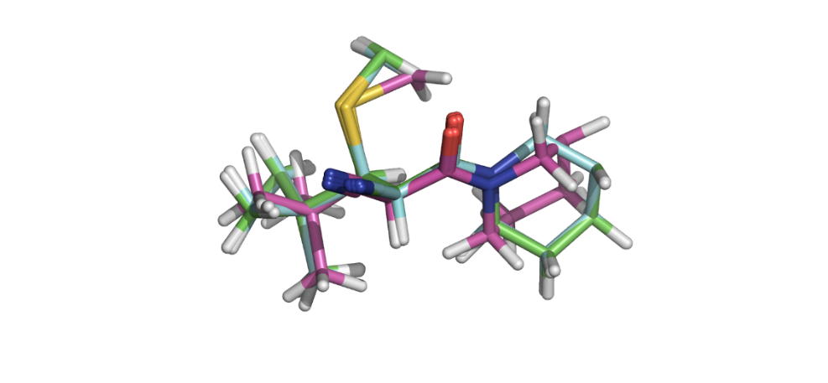

**Figure 2.6.** Superposition of core atoms of calculated **P3** (pink) and the two conformations of **3** present in the co-crystal structure conformations with BTK (A chain, green, and B chain, blue).

### Calculations of Thermodynamic Quantities of Thiol-Michael Additions of MeSH to the Acrylamide Inhibitors

The calculated thermodynamic and kinetic parameters for MeSH additions to the MAs are shown in Table 2.4, along with the corresponding kinetic parameters for dissociation of the inhibitors from their covalent BTK adducts. The $G$ values were obtained using Method J. A comparison between the predicted $ΔG_{rev}^{‡}$ values and the experimental values is given in Table 4. The identity of the base catalyst in the BTK binding reactions is not known with certainty. For the sake of convenience, methylthiolate was used as a model base to compute the $ΔG_{rev}^{‡}$ values. Further investigation on the importance of the choice of base will be considered in the next chapter.

Table 2.3. Comparison between calculated and experimental thermodynamic and kinetic parameters for thiol additions to Michael acceptors.

|  |  |  |  |  |
| --- | --- | --- | --- | --- |
| Michael acceptor | Calc.*a* | Calc.*a* | Calc. *a,b* | Expt. *a* |
| **R1** | -4.0 | 7.8 | 11.8 | 22.8 ± 0.2 |
| **R3** | -2.0 | 12.8 | 14.8 | >26.5 |
| **R4(7)** | -2.1 | 9.0 | 11.2 | 25.1 ± 0.1 (**4**)  25.4 ± 0.1 (**7**) |
| **R5** | -9.0 | 16.8 | 25.8 | >>26.5 |
| **R9** | -3.6 | 11.0 | 14.6 | 26.4 ± 0.1 |

*a*Values were reported in kcal/mol. *b*Values were calculated using methylthiolate as model base.

The experimental $ΔG_{rev}^{‡}$ values were calculated from the experimentally measured $t_{1/2}$ using equations (2) and (3). The $t_{1/2}$ values were computed from the dissociation curves tracking the percentage of BTK bound by the inhibitors over 108 hours. As exemplified in Chart 1.1 (page 20), the errors in the experimental $ΔG_{rev}^{‡}$ values are within 0.2 kcal/mol except for **3** and **5** which exhibited irreversible binding. Despite the same magnitude of the rounded $ΔG_{rev}^{‡}$ values, no recovery of **5** from its covalent adductwas observed experimentally, in contrast to the gradual recovery of **3**. Consequently, the data as a whole should be interpreted as semi-quantitative (Inhibitors **3**, **5**, and **9** have large $ΔG_{rev}^{‡}$, **4** and **7** have medium $ΔG_{rev}^{‡}$, while **1** has a small $ΔG_{rev}^{‡}$). The relative magnitude and ranking of the $ΔG_{rev}^{‡}$ values are thus more important than the absolute barriers in the comparison between the calculations and experimental data.

The calculated and experimental $ΔG_{rev}^{‡}$ values showed identical rankings, with only the ranks **R1** and **R4(7)** being reversed in the calculations. This is unexpected to an extent because the QM model systems do not include any of the environmental effects of the BTK binding site. However, a closer examination on the relative magnitudes of the predicted and experimental $ΔG_{rev}^{‡}$ values reveals that although the ranks follow approximately the same overall trend as the experiments, the calculated reactivities for some of the MAs differ more from the experimentally-observed reactivities than do others. This indicates that the intrinsic reactivities of the warheads do not fully account for the observed experimental behaviour. The factors not captured in the QM model systems likely comprise a combination of stabilising/destabilising effects that influence different adducts and TSs to different extent. These effects can potentially be determined through simulations of the full BTK-inhibitor systems, which will give an indication of how the binding site residues contribute to these environmental effects. The investigation would thus be continued in the next chapter.

**Figure 2.6.** Comparison between calculated (primary axis) and experimental (secondary axis) $ΔG_{rev}^{‡}$ values. Experimental data for **7** ( $ΔG_{rev}^{‡}$ = 25.4 kcal/mol) was omitted from the plot.

### Rationalisation of the Calculated Thiol-Michael Addition Barriers

In order to uncover factors that influence the calculated $ΔG^{‡}$ values, analyses were performed to identify any correlations between the predicted barriers and a range of electronic descriptors of the MAs.

#### Lowest Unoccupied Molecular Orbital Energies

The calculated $ΔG^{‡}$ values were first compared to the lowest unoccupied molecular orbital (LUMO) energies of the reactants (Figure 2.7). Most inhibitors fall close to the linear relationship, except two MAs, **R1** with the simplest warhead and **R9** with the most elaborate warhead. Overall, a reasonably strong correlation was observed ( $R^{2}$ = 0.84), although it is slightly weaker than what was observed previously in among acrylamide-containing compounds ( = 0.93).110 It is expected that lower LUMO energies of the inhibitors would correspond to faster thiol additions as the HOMO-LUMO energy gap with the nucleophilic thiolate will be smaller.

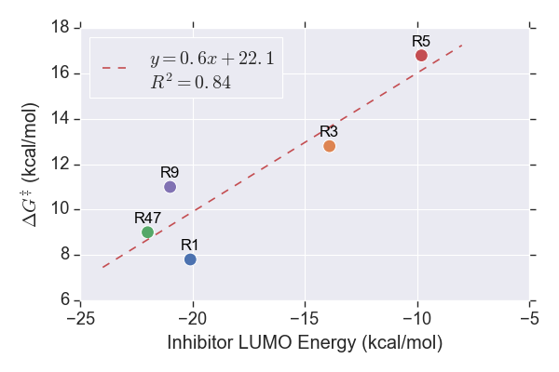

**Figure 2.7.** Plot of calculated $ΔG^{‡}$ against LUMO energy of the acrylamide inhibitor.

#### Earliness or Lateness of the Transition States

The distance between the sulfur atom of the methylthiolates and the electrophilic C $β$ of the MA indicates the earliness or lateness of the TS along the reaction coordinate. This could serve as a measure of how advanced the bond-forming interaction between the reactant molecules must be for the addition to proceed. A longer S-C distance implies that the TS is achieved earlier in the reaction path. The calculated $ΔG^{‡}$ values are plotted against the S-C distance in Figure 2.8 A negative correlation ( $R^{2}$ = 0.88) is found. This indicates that the strength of the interaction between the reactants has a strong influence on the addition barrier.

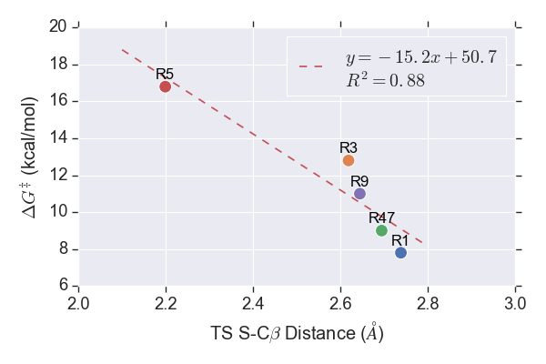

**Figure 2.8.** Plot of calculated $ΔG^{‡}$ against distance between sulfur of methylthiolates and $β$-carbon of the MAs in the TSs.

#### Charge on the $β$-Carbon

Conceptual DFT is next utilised to calculate global descriptors that measure the overall susceptibility of a molecular system to electrophilic attacks. The electrophilicity index, $ω$, a global descriptor devised by Parr111 to describe the extent of energy lowering upon uptake of electron density, is defined by equation (6):

|  |  |  |
| --- | --- | --- |
| $$ω=\frac{χ^{2}}{2η}$$ |  | (6) |

where $χ$ is electronegativity and $η$ is chemical hardness, which refers to the electron density concentration around a particular atom in line with the hard-soft acid-base (HSAB) concept.112 Both of the variables are calculated from the ionization potential (IP) and electron affinity (EA) of the molecule of interest, which are approximated to be the negatives of the LUMO and the highest occupied molecular orbital (HOMO) energies respectively according to Koopmans’ theorem.113

The electrophilicity of an atom in a molecule is anticipated to be inversely proportional to its electron density, which is commonly represented by partial atomic charges. An attempt was thus made to explore the correlation between the addition barriers and the partial atomic charge on the $β$-carbon of the MA along with $ω$ (Figure 2.9). Seven different charge calculation schemes were examined: Mulliken population analysis, natural bond orbital (NBO), Merz-Kollman, Hirshfeld, Charge Model 5 (CM5), quantum theory of atoms in molecules (QTAIM), and ChelpG. All of the charge schemes showed an inverse relationship with the $ΔG^{‡}$ values as expected, with the QTAIM charges returning the highest $R^{2}$ value (0.86). The $R^{2}$ values of other charge schemes range from 0.22 to 0.85. Overall, no exceptional correlation was found between charges and $ΔG^{‡}$ values. The correlation between the barrier and $ω$ ( $R^{2}$ = 0.73) is weaker than the what was observed among unsubstituted acrylamide-containing compounds ( = 0.87).110

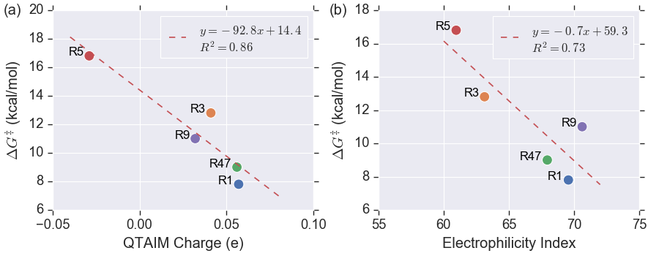

**Figure 2.9.** Plots of calculated $ΔG^{‡}$ against (a) QTAIM charges of $β$-carbon and (b) electrophilicity index of the MAs.

#### Distortion/Interaction Analysis

The distortion/interaction model of reactivity114 was used to analyse the reactivity trend across the investigated cyanoacrylamide MAs. In this model, the activation energy for a reaction, $ΔE^{‡}$, is understood as the sum of (i) the energies required to distort the reactants into their TS geometries, $ΔE_{d}^{‡}$, and (ii) the interaction energy between the distorted reactants in the TS complex, $ΔE_{int}^{‡}$, as shown in equation (7):

|  |  |  |
| --- | --- | --- |
| $$ΔE^{‡}= ΔE_{d}^{‡}+ΔE_{int}^{‡}$$ |  | (7) |

Plots showing the correlations between the computed $ΔG^{‡}$ and the distortion and interaction energies are shown in Figure 2.10.

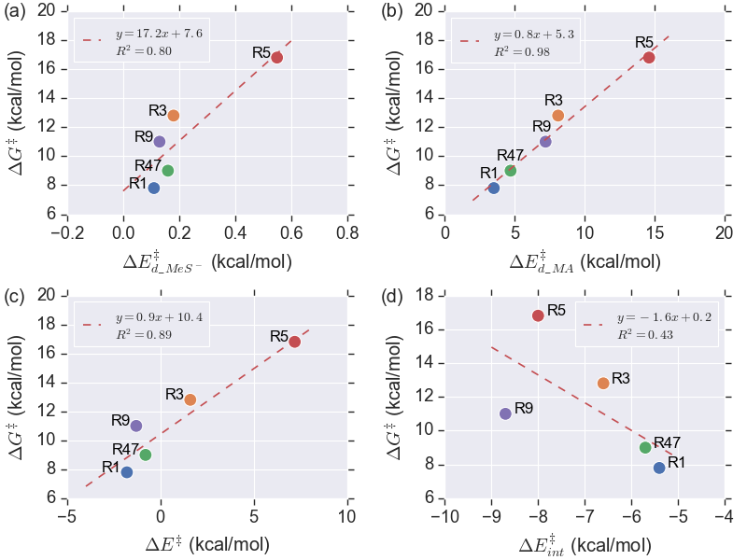

**Figure 2.10.** Plots showing the relationship between the computed $ΔG^{‡}$ and (a) the thiolate distortion energies, $ΔE_{d_{MeS}^{-}}^{‡}$, (b) the inhibitor distortion energies, $ΔE_{d_MA}^{‡}$, (c) $ΔE^{‡}$, and (d) $ΔE_{int}^{‡}$.

The amount of strain that the methylthiolate anion has to overcome to achieve the TS is small and varies little across the five acrylamides. One acrylamide, **R5**, has undergone a greater distortion to reach the TS compared to the other four. Despite the positive correlation observed ( $R^{2}$ = 0.80), the relative miniscule magnitudes of the $ΔE_{d_{MeS}^{-}}^{‡}$ do not influence the $ΔG^{‡}$ in any major way. A rather weak correlation ( $R^{2}$ = 0.43) was found from the regression analysis on $ΔE_{int}^{‡}$.

In contrast, the $ΔE_{d_MA}^{‡}$ values show a very strong correlation with the addition $ΔG^{‡}$ values, as evidenced by the $R^{2}$ value of 0.98. The $ΔE^{‡}$ values also exhibited a rather strong correlation with the predicted $ΔG^{‡}$ values ( $R^{2}$ = 0.89). The strong correlation implies that it is possible to use $ΔE^{‡}$ as a surrogate for $ΔG^{‡}$, which would be of great use later in the analysis of the full BTK-inhibitor complexes. Interestingly, some of the reactions displayed negative $ΔE^{‡}$ values. This result was attributed to the formation of low-energy vdW complexes prior to the formation of TS.

The investigations above have demonstrated that the intrinsic addition barriers for the thiol-Michael additions do correlate with certain molecular properties, with $ΔE_{d_MA}^{‡}$ being the most prominent one. The trends observed intuitively indicates that $ΔE_{d_MA}^{‡}$ is smaller when the LUMO energy of the MA is lower as the TS could be achieved earlier (longer S-C distance).

### Comparison between Predicted and Observed Kinetic and Thermodynamic Parameters

Overall, the irreversible acrylamide inhibitor **R5** exhibits much lower kinetic reactivity compared to the cyanoacrylamides. This is consistent with the understanding from previous work that the installation of electron-withdrawing groups at the $α$ position of acrylamides enhances their reactivities kinetically at the cost of destabilisation of the corresponding thiol adducts.44 The methyl- and *tert*-butyl-substituted cyanoacrylamides **R1** and **R3** are almost always on the opposite extremes in the kinetic reactivity trends predicted for all the properties tested among the cyanoacrylamides, with **R1** being the most reactive and **R3** being the most inert. This is in agreement with the experimental observation where **R3** had a longer RT than **R1**. The values predicted for **R9**, which had a long but reversible duration of action in the experiment,are largely similar to those of **R3**, being slightly less reactive in most cases. The reactivity differences between certain pairs of the inhibitors (**1** vs **3**, **3** vs **9**, and **5** vs the cyanoacrylamides) are thus predicted successfully.

Compared to the experimentally observed kinetic reactivities in the reverse reaction, the rankings of the elimination rates predicted by the QM calculations are reproduced qualitatively, but the relative differences in magnitude of elimination barriers between the inhibitors do not agree well. It was therefore anticipated that the study on the dynamics of the full BTK-inhibitor systems, reported in the next chapter, would shed some light on the latter aspects.

# INVESTIGATIONS OF THE BINDING OF COVALENT INHIBITORS TO BTK

This chapter covers the MD simulations of the binding of acrylamide inhibitors to BTK. Systems with different bound forms (BTK with neutral/anionic noncovalently/covalently bound inhibitors) were simulated to study the conformational changes along the reaction coordinates. The key properties of interest in the simulations are the identity of the base catalyst, the strains induced in the inhibitors upon binding, and the factors affecting the arrival at TS geometries.

## Methods

### General Aspects

Production MD simulations were conducted using Assisted Model Building with Energy Refinement Version 18 (AMBER18) *pmemd.cuda* program115-117 installed on a Dell EMC high-performance computer. The preparation of the systems and energy minimisations were carried out using GROMOS++ programs version 1.4.0.118 Twelve systems in total were considered. These comprised four systems for inhibitors **1** and **3**, namely, (i) the noncovalent complex with neutral Cys481 thiol, (ii) the noncovalent complex with deprotonated Cys481 thiolate, (iii) the covalently bound anionic inhibitor-BTK adduct (enolate), and (iv) the neutral covalent adduct, along with noncovalently bound BTK complexes with inhibitors **4**, **5**, **7**, and **9** with Cys481 deprotonated.

### Preparation of the System

Protein topology parameters were obtained from the Groningen Molecular Simulation Version 11 (GROMOS11) 54A7 force field119 in the form of interaction function parameter (ifp) and molecular topology building block (mtb) files from the Automated Topology Builder (ATB) version 3.0 web server.120,121 ATB was also used to generate the topology parameters of inhibitors **1**, **3**, **4**, **5**, **7**, and **9** bothin the form of the unreacted compounds and covalently bonded with a cysteine residue. The geometries were optimised at the B3LYP/6-31G*122 level of theory in water using PCM.123,124 The electrostatic potential (ESP) was then calculated using the optimised geometry, and the charges were obtained from the ESP by least-squares fitting.120

The systems simulated were built based on the X-ray co-crystal structure of BTK with inhibitor **3** (PDB accession number: 4YHF5). The structure consisted of the BTK dimer covalently bound to two molecules of **3**. Missing residues were built using PyMOL.125 The N termini were modelled as NH3+ and the C termini as COO-. Swiss PDB Viewer was employed to add missing atoms through reconstruction of the side chains.126 Molecules other than BTK or **3** such as SO42- anions and ethylene glycol present due to the buffers used during protein crystallisation were removed. The warhead of **3** was modified to give the other inhibitors. Conversion of the covalently bound inhibitors back to the reactant state was achieved by removing the extra proton acquired during thiol addition and adjusting the orbital hybridisation. The topology files of BTK monomers and inhibitors were generated separately using the *make_top* program and combined using the *com_top* program. The protonation state of each residue was based on predicted $pK_{a}$ values obtained using PROPKA version 3.1.127,128 A residue was protonated if its $pK_{a}$ value was equal to or lower than physiological pH (7.4). The residue and atom names of **3** in the PDB file were then updated to match the mtb file obtained from the ATB. The *pdb2g96* program was used to generate a coordinate file of the system in GROMOS96 format followed by the addition of hydrogen atoms by the *gch* program.

The protein and inhibitors were first energy minimised in vacuum over 5000 steps using steepest descend method with a tolerance of 0.01 kJ/mol before solvation in a rectangular box of simple point-charge (SPC) water with a minimum distance of 14 Å between the protein and the wall using the *sim_box* program. For the systems involving deprotonated species, the overall charge of the system was -2 overall. Neutralisation was achieved by progressively replacing water molecules with the highest potential with sodium ions. The solvated system was then energy minimised again for 5000 steps. A positionally restrained energy minimisation was then carried out by first applying a harmonic potential to the coordinates of the protein structure. Full details of the parameters used are included in Appendix 6.1. The GROMOS system topologies (.top) and coordinates (.cnf) were converted into AMBER-compatible format (.prmtop and .mdcrd, respectively) utilising the topology converter on the ATB web server.

### Setup for MD Simulation

The systems were first equilibrated in the canonical (NVT) ensemble for 100 ps. The velocities of the atoms were initialised based on the sampling from Boltzmann distribution at 298.15 K. The temperature of the system was then increased to 310.15 K and maintained constant with a Berendsen thermostat.129 A 2 ns isobaric-isothermal (NPT) equilibration with a pressure of 1 atm maintained using a Berendsen barostat129 was then carried out. This was followed by 12 ns NVT equilibration. All-atom NVT simulations was carried out for 100 ns for each system. The simulation temperature of 310.15 K and pressure of 1 atm were maintained using coupling time constants of 0.1 and 0.5 respectively. The isothermal compressibility of the system was set to 45.75 × 10-6 bar-1. Periodic boundary conditions (PBC) were imposed to avoid edge effects. Long-range Coulomb interactions were handled using the particle mesh Ewald (PME) method.130 The SHAKE algorithm131 with tolerance of 10-5 was utilized to constrain the bond involving hydrogen atoms in the protein. A time step of 1 fs was used. Both the Coulomb and the vdW interactions were truncated at 1.4 nm. A dielectric constant of 1.0 was used. The coordinate trajectories were recorded every 1 ps. The SETTLE algorithm was employed to constrain the geometry of water molecules.132

### Trajectory Analysis

The trajectories and structural properties of the simulated systems were analysed using the CPPTRAJ program133 and plotted using Python scripts written as required during the project. The systems were visualised using the Visual Molecular Dynamics (VMD)134 analysis toolkit.

The Boltzmann averaged energies of the geometries of inhibitors **1** and **3** sampled from the MD simulations and their most stable geometries as determined by MM conformational sampling were calculated using equation (4) on page 27. This was achieved by first identifying fifteen clusters of the inhibitors from the simulation trajectories based on their coordinates RMSD using an unsupervised machine learning algorithm known as k-means clustering. The single point energy (SPE) of each geometry prior to and after MM geometry optimisation was then calculated using the OPLS3e force field in the MacroModel software and the Boltzmann averaged energy was computed. This was then compared to the Boltzmann averaged energy of the top fifteen conformers ranked by stability as obtained from the conformational sampling using the same force field.

## Results and Discussions

### Identification of the Potential Base Catalyst

The base catalyst plays an important role in the mechanism of thiol-Michael reactions that proceed via the conventional mechanism. At the beginning of this project, the identity of the base(s) involved in deprotonation of Cys481 in the forward addition reaction and in deprotonation of the covalent adduct in the elimination reaction, which is not necessarily the same, was unknown. An analysis of the MD trajectories was thus performed to search for potential base species that might participate in the thiol addition/elimination.

#### Distance from Potentially Basic Residues

A common understanding assumes that the “basic” amino acid residues (histidines, lysines, and arginines) are unable to act as basic catalysts as they tend to be protonated at physiological pH.135 However, there is growing evidence that these kinds of residues may act as biological base catalysts. Schlippe and Hedstrom136 had reported solvent accessible arginines adjacent to carboxylate groups acting as general bases while Kenyon et al.137 found that the $pK_{a}$ of lysines could be reduced significantly due to spatial proximity to ammonium groups. Taking this into consideration, when searching for possible participating bases, the candidates considered were histidines, lysines, arginines, glutamates, and aspartates.

Possible candidates for the base catalyst of the forward addition reaction were identified by measuring the distance of the above-mentioned residues from the thiol proton of Cys481 during the simulations of the noncovalently bound BTK-inhibitor systems. The nitrogen atoms of the guanidine groups of Arg146 and Arg424 were observed to approach as close as 2-3 Å from the thiol protons for one brief moment in the simulations. This gives rise to the prospect that one or both of these arginines could be the base that deprotonates Cys481 to catalyse the thiol additions. The relevant data about the distances measured are recorded in Appendix 6.3.1.



**Figure 3.1.** Snapsnots of the simulations capturing the closest distances between arginines potentially acting as base catalysts and (a) Cys481 thiol protons and (b) C $α$ protons.

The eliminations of thiol from the covalently bound adducts of **1** and **3** were then studied by looking at how close the charged moieties of the above amino acid types approached the C $α$ proton of the bound inhibitors during the 100 ns MD simulations. The closest interactions for both systems involved residues Arg384 and Arg422 and were about 4-5 Å. These distances are still relatively far away from the expected geometry of a deprotonation TS (expected B-H-C distance of about 3 Å). Nevertheless, these arginines are as yet the most likely base candidates for deprotonating the C $α$ protons, if the base is indeed a residue from the protein. Considering that it took more than 200 hours for **3** to dissociate from BTK experimentally, and that there is no obvious candidate for an internal base within the binding site, it is reasonable to hypothesise that the conformation observed in the X-ray co-crystal structure of the bound adduct must undergo a significant conformation change before the elimination can take place. Multiple thermodynamically accessible states of BTK had been reported in the literature. The X-ray structures solved by Taunton et al. is most similar to the “C-helix-out” inactive conformation found by Silvian et al.,138 but conformations similar to the “apo” form was sampled in some MD simulations of the dimer. Longer simulations would be needed to sample the protein conformational dynamics. Techniques such as simulated annealing could potentially help to overcome the barrier to conformational interconversion.

Alternatively, the base could be an external one from the solution, rather than internally from the protein. However, this requires the protons to be abstracted to remain solvent exposed for long enough. Considering that the inhibited BTK dimer folds into the apo state for most of the simulations, the probably of this happening is rather low. The $pK_{a}$ of Cys481 in the crystal structure, minimum energy geometries sampled in the noncovalently bound BTK by inhibitors **1** and **3** calculated by PROPKA are 11.99, 8.87 and 9.62, respectively, indicating that it is unlikely deprotonated in the resting state of the enzyme.

#### Transition States for C $α$ Proton Abstractions from the Covalent Adducts

Assuming that one or more of the arginines identified in section 3.2.1.1 indeed catalyses the thiol addition and elimination reaction, QM calculations were performed to find the TS structures and the energy barriers for the deprotonation of the covalent adducts by a model Arg base. The structures are shown in Figure 14. The breaking C-H bonds of the inhibitors except **TSD9** are perpendicular to the C=O bonds, enabling stabilisation through conjugation between the developing carbanion and the $π^{*}$ orbital of the C=O bonds. The ideal geometry is likely inaccessible for **TSD9** due to steric hindrances. However, its C-H bond was found to be in plane with the C=O bond, which allows stabilisation from negative hyperconjugation, where the electron pair of the broken bond interacts with the low-lying empty C-O σ* orbital.



**Figure 3.1.** Structures of the thiol adduct deprotonation TSs.

The possibility that thiol elimination takes place through alternative base free mechanisms such as six-membered and four-membered intramolecular proton transfers was also considered by calculating the elimination barriers for comparison. In comparison with the conventional base-catalysed elimination mechanism, the $ΔG_{rev}^{‡}$ values for the intramolecular proton transfers are much higher, with the four-membered TS being the highest in energy as expected. The six-membered TSs are at least 8.1 kcal/mol less stable than the TSs of the rate-determining step in the conventional mechanism and the four-membered TSs are at least 16.7 kcal/mol higher in energy than the six-membered TSs. The calculated results are included in Appendix 6.3.2. This observation indicates that intramolecular proton transfers are unlikely to occur at biologically relevant temperatures.

Scheme 3.1. Thiol Elimination via Intramolecular Proton Transfers



#### Construction of Complete Energy Profiles

Putting all of the information together, the energy profiles for the base-catalysed thiol-Michael additions to the truncated MAs are shown in Figure 15.



**Figure 3.2.** Energy profiles of thiol-Michael additions of methanethiols to acrylamides **R1**, **R3**, **R4(7)**, **R5**, and **R9**, calculated at M06-2X/6-311+G(d,p) level of theory.

The energy profiles shown in Figure 15 differ qualitatively from previous computational studies on cyanoacrylamide thiol-Michael additions,44 in that the energies of the intermediate enolate species derived from cyanoacrylamides **R1**, **R3**, **R4(7)**, **R5**, and **R9** appear to be higher than the energies of the products, which is consistent with the experimental findings as the thiol adducts were isolated instead of intermediates. The discrepancy in the kinetic parameters can be attributed to the choice of the base species (guanidine here and DBU in the previous work) as the stabilities of the thiolate ions and intermediate enolate (plus BH+) depend on the p*K*a of the model base. The absolute magnitudes of the kinetic parameters derived from the energy profiles in Figure 15 are only relevant if the “true” base is guanidine, but their relative magnitudes may still be expected to be qualitatively correct. On the other hand, the thermodynamic parameters of the overall equilibrium are not affected by the identity of the base. The thiol adducts for the four cyanoacrylamides are found to be 3.9-5.9 kcal/mol more stable than the reactants while the product of the thiol addition to the acrylamide **R5** is much more stabilised (-10.8 kcal/mol). An unanticipated result was that the thiol adduct deprotonation TSs of **P4(7)** (**TSD4(7)**, green) and **P9** (**TSD9**, purple) are higher in energy than **TS4(7)** and **TS9** respectively, which could possibly be due to greater strains in their geometries or lack of intermolecular stabilisation compared to the other TSs. This renders the deprotonation step of the thiol elimination the rate determining step (RDS) for all inhibitors except **P3**.

With the RDSs established, the trend of the predicted $ΔG_{rev}^{‡}$ now matches the experimentally observed trend to a greater extent, with **R3** being the only outlier. The incorporation of guanidine as the catalyst has greatly improved the agreement between the calculated $k_{off}$ and the observed RT. That said, it should be kept in mind that the identity of the RDS is highly dependent on the choice of the base catalyst. A change in this might very well alter the predicted trend significantly. Comparing the two closest distance snapshots (Figure 3.1) for **1** and **3**, it could be seen that the guanidine moiety is sterically hindered by the *tert*-butyl group to approach the C $α$ proton. This suggests that the thiol elimination of **3** could involve a different species, which could further improve the prediction of the $ΔG_{rev}^{‡}$ trend.

**Figure 2.6.** Comparison between calculated and experimental $ΔG_{rev}^{‡}$ values. Experimental data for **7** ( $ΔG_{rev}^{‡}$ = 25.4 kcal/mol) was omitted from the plot.

### Conformational Changes that Occur Upon Binding of Cyanoacrylamides 1 and 3 to BTK

#### Molecular Strain Induced Upon Binding of Inhibitors to BTK

The distortion/interaction analysis in Chapter 2 had revealed a strong correlation between the magnitude of the barrier for thiol addition and the distortion energy of the MA. In light of this correlation, the conformations of the MAs in the MD simulations were analysed in order to determine how much internal strain is introduced upon binding to BTK. A key question was how the structural differences in the warhead of the inhibitors affects the distortion of the bound inhibitors from their most stable structures. It should be noted that only the warhead of the inhibitors are relatively more flexible in the actual bound conformations system while the scaffolds and linkers have a more or less fixed geometry due to various interactions with the active site residues.

Figure 3.3 shows the comparison between the conformers from MD simulations of noncovalently bound BTK and conformational sampling for inhibitors **1** and **3**. It is seen that prior to its binding to the active site of BTK, the inhibitors **1** and **3** have to “unfold” from their most stable ground state geometries into a significantly different conformation in which certain stabilising intramolecular interactions have been lost (e.g. C-H··· $π$ interactions between the methyl protons of the capping group and the *para*-substituted phenyl group of **3**). These deviation of the binding geometry from the most stable structure for the inhibitor as a whole is thus entangled with intramolecular interactions.

The hypothetical ideal position of the S-Me group calculated is unlikely to be attained in the actual structure as Cys481 is geometrically constrained by the other residues.





**Figure 3.3.** Superposition of the conformers from MD simulations of noncovalently bound BTK (left) and MacroModel conformational sampling (right) for inhibitors **1** (upper) and **3** (lower)**.**

### Trajectory Analysis of BTK Noncovalently Bound to Different Acrylamide Inhibitors

The trajectories of the noncovalently bound BTK dimers were analysed to better understand the factors affecting their ability to form a covalent bond to Cys481. The features investigated were the rotational barrier about the C=C-C=O bonds of inhibitors and the distance between atoms participating in the chemical reaction.

#### Torsion of the C=C-C=O Bonds

In order to form a covalent bond, the nucleophilic thiolate of Cys481 has to approach the electrophilic carbon of the warhead. Another feature identified as being important was the ability of the warhead to rotate about the C=C-C=O bond. Flexibility in this torsion could be expected to increase the likelihood of the inhibitor of achieving a geometry resembling the TS for thiol addition by allowing faster sampling of different conformations. The torsion angles of the bond between the C=O carbon and $α$-carbon were measured for all noncovalently bound inhibitors and are presented as distribution plots in Figure 17.

The dihedral angle of **3** was found to vary the least among the inhibitors, followed by **9**. Upon visualisation, the dihedral rotation in **3** was found to have been hindered by steric clashes between the *tert*-butyl groups and the *iso*-propyl group of a leucine and C-terminal of asparagine throughout the simulation. This is different from the case in **9**, in which the torsional barrier arises from the interactions of the polar functional groups (oxetane and nitrile) with the solvent, namely hydrophobic effect. On the other hand, for inhibitor **5**, the torsion angle distribution spans a range of 180°, suggesting a small dihedral rotation barrier in the binding site. Inhibitor **5** may thus be predicted to undergo relatively faster thiol addition due to its greater flexibility within the binding site to form an interaction with Cys481. Conversely, the relatively smaller spread in the distributions of **3** and **9** suggests that the thiol additions might be slower for these inhibitors. It is seen that for **1**, **3**, **7**, and **9**, the angles follow approximately normal distributions. Unlike **4**, the distribution peaks with opposite signs for **7** and **9** do not interconvert, suggesting that the different states sampled were separated by high rotational barriers. It is thus predicted that an absolute configuration of *S* in the linker (**4**) allows faster thiol addition compared to its diastereomer (**7**).

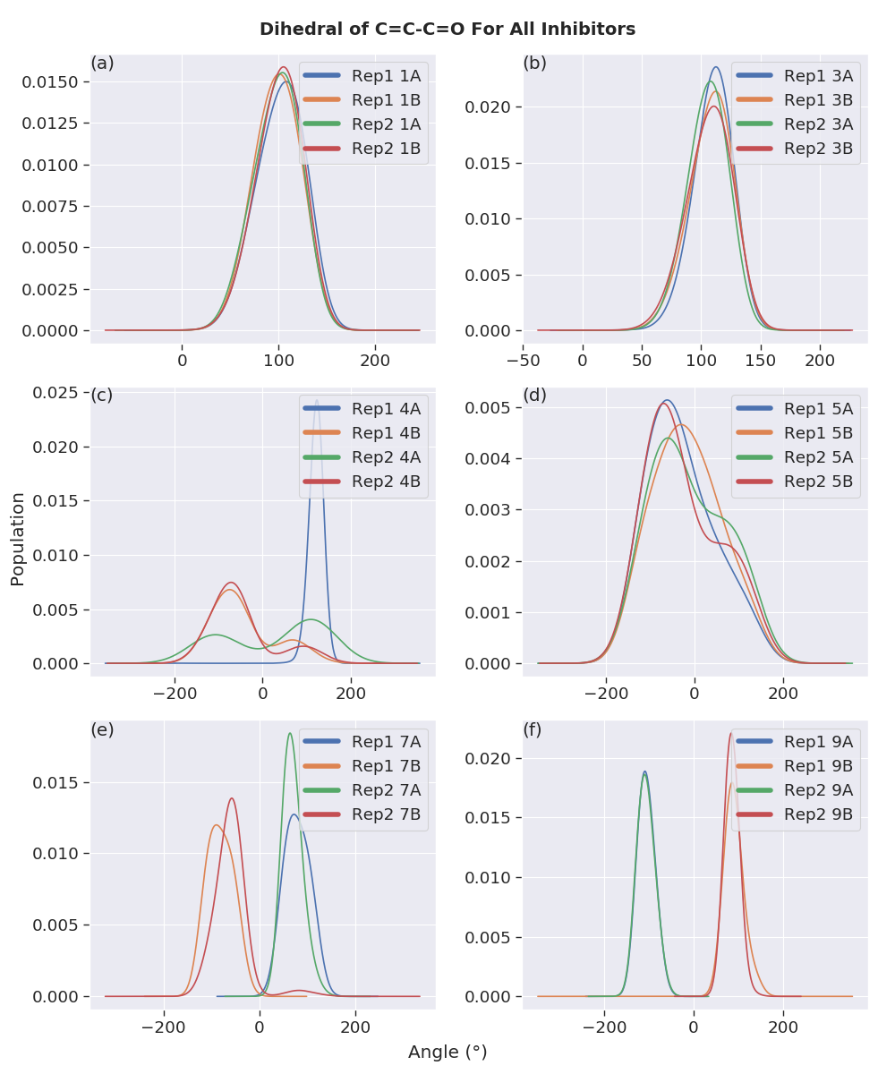

**Figure 3.5.** Distributions of the C=C-C=O dihedral angles throughout the 100 ns MD simulations of noncovalently bound BTK inhibitors. A and B denotes the inhibitors bound to the two different monomers of the BTK dimer while the number in front refers to the identity of the inhibitor.

#### Distance of Cys481 Sulfur Atom from the Electrophilic Carbon

The distance between the atoms that participate in the covalent bond formation event is a crucial indicator of the possibility of achieving the TS geometries. Figure 18 shows the distribution of the distances between the Cys481 sulfur and the electrophilic carbon of the inhibitors. The average S-C distances vary from 4-8 Å, with the distance between the thiolate sulphur and $β$-carbon of inhibitors **3** being the shortest (3.8 Å). Based on the QM calculations, the hypothetical ideal S-C distances in the TS are about 2.7 Å (**R1**), 2.6 Å (**R3**), 2.7 Å (**R4(7)**), 2.2 Å (**R5**), and 2.6 Å (**R9**). None of the simulations contained any frames in which the S-C distance was close enough for the TS to be achieved. Nevertheless, the fluctuations of the distance could give an indication of the flexibility of the two reactive moieties within the binding site. In agreement with theobservations made in the investigation on the torsional barriers, the fluctuation in the S-C distance throughout the simulation is the smallest for **3** (about 1 Å) and largest for **5** (about 7 Å). Inhibitors **1**, **4**, and **7** exhibited fluctuations of about 4 Å, while **9** deviates for about 3 Å from its average S-C distance throughout the simulations. **5** is thus predicted to have the fastest thiol addition while **3** has the slowest addition rate. Since the forward addition rate constants were not reported experimentally, the predictions would await experimental testing.

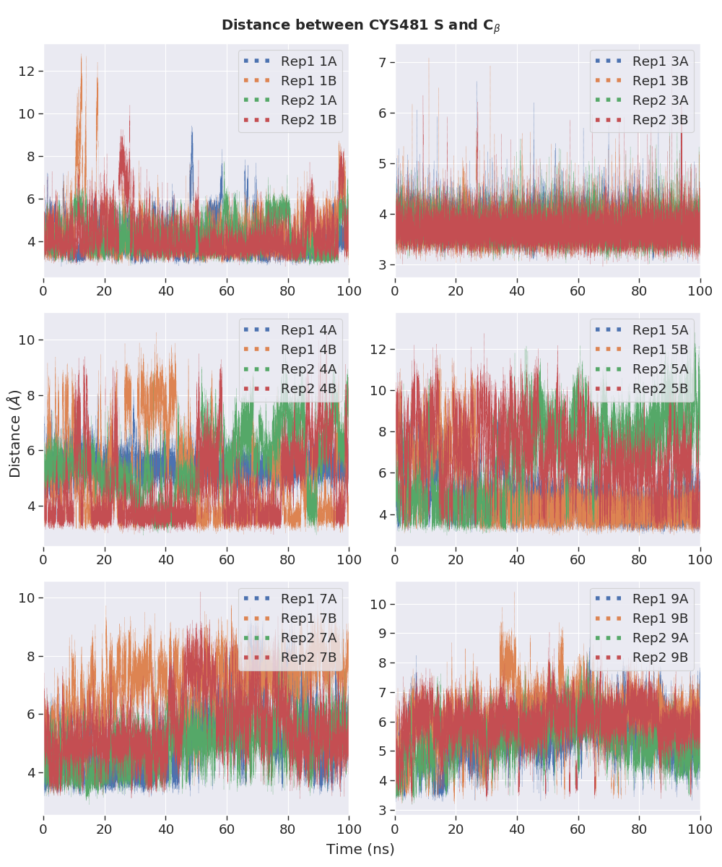

**Figure 3.6.** Distance between the sulfur atom of the Cys481 thiolate and the electrophilic $β$-carbon of the inhibitors.

# CONCLUSIONS AND FUTURE DIRECTIONS

## Conclusions

Computational studies with QM and MD have been performed to investigate the reactivities of cyanoacrylamide inhibitors with BTK. The aim was to understand the factors that determine the kinetics and thermodynamics of thiol addition and elimination. The utilisation of a variety of computational tools including QM calculations and MD simulations have provided some insights into the intrinsic reactivity of the inhibitors.

The investigations reported herein have uncovered some electronic features that could potentially serve as indicators of an acrylamide’s reactivity towards BTK Cys481. However, the establishment of the cause-and-effect relationship between these factors and the thiol addition barriers would require the corroboration from more extensive experimentation. For further analysis, the interaction energy could be further dissected into individual components, including electrostatic, polarisation, exchange repulsion, and charge transfer interactions.139 The independent investigations on each aspect of these noncovalent interactions might allow pinpointing of the component that contributed most significantly to thiol-Michael additions.

The failure of MM force field to locate the lowest energy geometry of **R1** implies that data visualisation is likely one of the most important aspects currently in the field of computational chemistry due to its still early stage of methodology development. Software users always to consider whether the results obtained are both physically reasonable and match what might be expected based on related chemical systems. Validation of results against experimental observations or alternative calculations should always be done where possible.

Arginine was proposed to be the base participating in the Michael reactions and a reaction profile was calculated based on this assumption. However, to verify the identity of the base catalyst and further study the mechanism of the reactions, an approach which allows the electrostatic and steric effects of the protein on the reaction to be accounted for while ensuring accurate representation of the electronic structure in the vicinity of the reacting atoms would be required. The internal strains of the warheads of inhibitors **1** and **3** were found to vary greatly throughout the simulations. Further analysis on the properties of the MD systems simulated could potentially reveal the interactions between the inhibitors and their environments that contribute to the stabilisation of the highly-strained inhibitors. This finding again stresses the importance of gaining a dynamic picture of a system, as supposed to inferring from a static, averaged image of a considerably flexible system alone.

## QM/MM Studies

Hybrid QM/MM methods were designed to address the limitation of pure QM calculations which are restricted to systems containing up to a few hundred atoms and the inability of MM force fields to describe bond-breaking/forming reactions. As illustrated in Figure 10, the basic principle of these methods is to treat the chemically active region at QM level whereas the interactions within the protein surroundings or the explicit solvent molecules are represented using force fields, which allow reduced computation through simplification of the underlying physics. QM/MM methods have received extensive use in recent years as a versatile tool for the study of enzymatic reaction mechanisms.140-146 It is thus anticipated that a similar study on BTK would provide insightful details about the inhibition mechanism of BTK of use to future research.

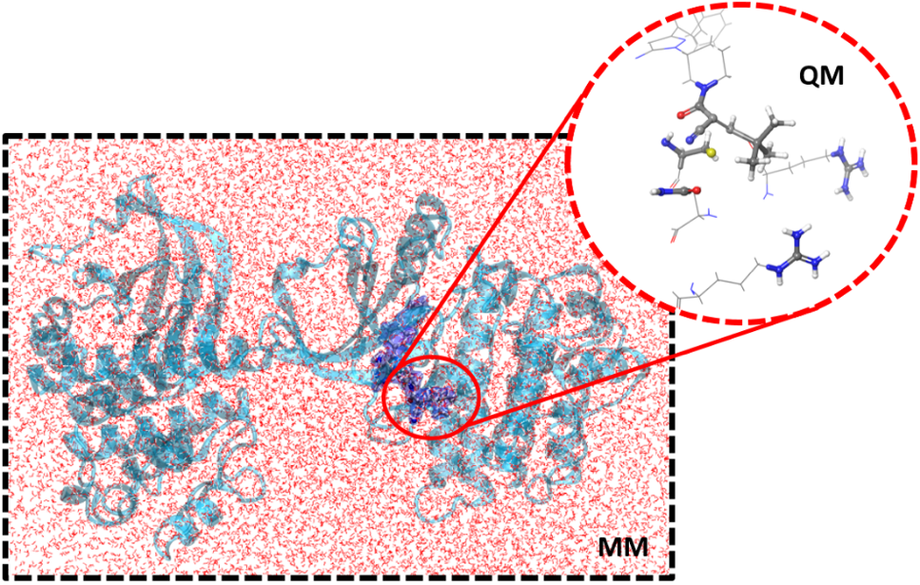

**Figure 10.** Illustration of the QM/MM concept.

### Location of TS Structures

A QM/MM system could be built for each inhibitor based on a snapshot of the MD simulations of the covalently and noncovalently bound BTK for more detailed studies on the thiol eliminations and additions, respectively. The frame should be selected such that the positions of the reactive moieties are close to the TS geometries, meaning the current MD simulations would need to be extended to sample these configurations. More accurate reaction profiles for the Michael reactions could then be calculated. This would allow for the verification of the participating base, the illumination of the roles of specific residues near the binding site, and also the location of TS structures. Once the TS structures of the Cys481 thiol additions/eliminations to the inhibitors areidentified, the calculated kinetic parameters could be compared to the experimentally measured RT of the inhibitors for verification. The variations in reaction for different warheads could also be examined through structural modification of the warheads.

### Selectivity of Inhibitor 9 for BTK

The structural features responsible for the apparent kinase selectivity of **9** for BTK over other kinases could potentially be studied from a comparison of the binding of **9** to other kinases such as EGFR, ITK and TXK following the examination of the binding site effects. The QM/MM systems could be constructed readily from the widely available X-ray crystal structures of the unbound proteins. The approach developed in the study of the selectivity of **9** would serve as the foundation for future studies of the selectivities of other inhibitors, providing a broader evaluation of the factors that influence selectivity.

Visualisation of the trajectories of the BTK dimer revealed that the interactions between the dimer have brought the monomers closer to each other. As shown in Figure 19, this conformation effectively locked the one of the inhibitors in place, such that the release of the inhibitor requires another major change in the conformation of the dimer.

# REFERENCES

1. Potashman, M. H.; Duggan, M. E. *J. Med. Chem.* **2009,** *52*, 1231-1246.

2. Smith, A. J. T.; Zhang, X.; Leach, A. G.; Houk, K. N. *J. Med. Chem.* **2009,** *52*, 225-233.

3. Singh, J.; Petter, R. C.; Baillie, T. A.; Whitty, A. *Nat. Rev. Drug Discov.* **2011,** *10*, 307-317.

4. Powers, J. C.; Asgian, J. L.; Ekici, Ö. D.; James, K. E. *Chem. Rev.* **2002,** *102*, 4639-4750.

5. Bradshaw, J. M.; McFarland, J. M.; Paavilainen, V. O.; Bisconte, A.; Tam, D.; Phan, V. T.; Romanov, S.; Finkle, D.; Shu, J.; Patel, V.; Ton, T.; Li, X.; Loughhead, D. G.; Nunn, P. A.; Karr, D. E.; Gerritsen, M. E.; Funk, J. O.; Owens, T. D.; Verner, E.; Brameld, K. A.; Hill, R. J.; Goldstein, D. M.; Taunton, J. *Nat. Chem. Biol.* **2015,** *11*, 525-531.

6. Serafimova, I. M.; Pufall, M. A.; Krishnan, S.; Duda, K.; Cohen, M. S.; Maglathlin, R. L.; McFarland, J. M.; Miller, R. M.; Frödin, M.; Taunton, J. *Nat. Chem. Biol.* **2012,** *8*, 471-476.

7. Tóth, L.; Muszbek, L.; Komáromi, I. *J. Mol. Graphics Modell.* **2013,** *40*, 99-109.

8. Wright, P. M.; Seiple, I. B.; Myers, A. G. *Angew. Chem. Int. Ed.* **2014,** *53*, 8840-8869.

9. Kahan, F. M.; Kahan, J. S.; Cassidy, P. J.; Kropp, H. *Ann. N.Y. Acad. Sci.* **1974,** *235*, 364-386.

10. Uetrecht, J. *Chem. Res. Toxicol.* **2008,** *21*, 84-92.

11. Uetrecht, J. *Chem. Res. Toxicol.* **2009,** *22*, 24-34.

12. Chen, M.; Suzuki, A.; Borlak, J.; Andrade, R. J.; Lucena, M. I. *J. Hepatol.* **2015,** *63*, 503-514.

13. Yuan, L.; Kaplowitz, N. *Clin. Liver Dis.* **2013,** *17*, 507-518.

14. Mintzer, D. M.; Billet, S. N.; Chmielewski, L. *Adv. Hematol.* **2009,** *2009*, 1-11.

15. Barf, T.; Kaptein, A. *J. Med. Chem.* **2012,** *55*, 6243-6262.

16. Mah, R.; Thomas, J. R.; Shafer, C. M. *Bioorg. Med. Chem. Lett.* **2014,** *24*, 33-39.

17. Kalgutkar, A. S.; Dalvie, D. K. *Expert Opin. Drug Discov.* **2012,** *7*, 561-581.

18. Copeland, R. A.; Pompliano, D. L.; Meek, T. D. *Nat. Rev. Drug Discov.* **2006,** *5*, 730-739.

19. Tummino, P. J.; Copeland, R. A. *Biochemistry* **2008,** *47*, 5481-5492.

20. Zhang, R.; Monsma, F. *Expert Opin. Drug Discov.* **2010,** *5*, 1023-1029.

21. Guo, D.; Hillger, J. M.; Ijzerman, A. P.; Heitman, L. H. *Med. Res. Rev.* **2014,** *34*, 856-892.

22. Copeland, R. A. *Expert Opin. Drug Discov.* **2010,** *5*, 305-310.

23. Lu, H.; Tonge, P. J. *Curr. Opin. Chem. Biol.* **2010,** *14*, 467-474.

24. Vilums, M.; Zweemer, A. J. M.; Yu, Z.; de Vries, H.; Hillger, J. M.; Wapenaar, H.; Bollen, I. A. E.; Barmare, F.; Gross, R.; Clemens, J.; Krenitsky, P.; Brussee, J.; Stamos, D.; Saunders, J.; Heitman, L. H.; Ijzerman, A. P. *J. Med. Chem.* **2013,** *56*, 7706-7714.

25. Swinney, D. C. *Nat. Rev. Drug Discov.* **2004,** *3*, 801-808.

26. Kahan, T.; Eliasson, K. *Am. J. Hypertens.* **1999,** *12*, 1188-1194.

27. Kohout, T. A.; Xie, Q.; Reijmers, S.; Finn, K. J.; Guo, Z.; Zhu, Y.-F.; Struthers, R. S. *Mol. Pharmacol.* **2007,** *72*, 238-247.

28. Bauer, R. A. *Drug Discov. Today* **2015,** *20*, 1061-1073.

29. Bryant, J.; Post, J. M.; Alexander, S.; Wang, Y.-X.; Kent, L.; Schirm, S.; Tseng, J.-L.; Subramanyam, B.; Buckman, B.; Islam, I.; Yuan, S.; Sullivan, M. E.; Snider, M.; Morser, J. *Thromb. Res.* **2008,** *122*, 523-532.

30. Smith, C. I.; Baskin, B.; Humire-Greiff, P.; Zhou, J. N.; Olsson, P. G.; Maniar, H. S.; Kjellén, P.; Lambris, J. D.; Christensson, B.; Hammarström, L. *J. Immunol.* **1994,** *152*, 557-565.

31. Mohamed, A. J.; Yu, L.; Bäckesjö, C.-M.; Vargas, L.; Faryal, R.; Aints, A.; Christensson, B.; Berglöf, A.; Vihinen, M.; Nore, B. F.; Edvard Smith, C. I. *Immunol. Rev.* **2009,** *228*, 58-73.

32. Hallek, M.; Shanafelt, T. D.; Eichhorst, B. *Lancet* **2018,** *391*, 1524-1537.

33. Wang, M. L.; Rule, S.; Martin, P.; Goy, A.; Auer, R.; Kahl, B. S.; Jurczak, W.; Advani, R. H.; Romaguera, J. E.; Williams, M. E.; Barrientos, J. C.; Chmielowska, E.; Radford, J.; Stilgenbauer, S.; Dreyling, M.; Jedrzejczak, W. W.; Johnson, P.; Spurgeon, S. E.; Li, L.; Zhang, L.; Newberry, K.; Ou, Z.; Cheng, N.; Fang, B.; McGreivy, J.; Clow, F.; Buggy, J. J.; Chang, B. Y.; Beaupre, D. M.; Kunkel, L. A.; Blum, K. A. *New Engl. J. Med.* **2013,** *369*, 507-516.

34. Di Paolo, J. A.; Huang, T.; Balazs, M.; Barbosa, J.; Barck, K. H.; Bravo, B. J.; Carano, R. A. D.; Darrow, J.; Davies, D. R.; DeForge, L. E.; Diehl, L.; Ferrando, R.; Gallion, S. L.; Giannetti, A. M.; Gribling, P.; Hurez, V.; Hymowitz, S. G.; Jones, R.; Kropf, J. E.; Lee, W. P.; Maciejewski, P. M.; Mitchell, S. A.; Rong, H.; Staker, B. L.; Whitney, J. A.; Yeh, S.; Young, W. B.; Yu, C.; Zhang, J.; Reif, K.; Currie, K. S. *Nat. Chem. Biol.* **2010,** *7*, 41-50.

35. Honigberg, L. A.; Smith, A. M.; Sirisawad, M.; Verner, E.; Loury, D.; Chang, B.; Li, S.; Pan, Z.; Thamm, D. H.; Miller, R. A.; Buggy, J. J. *Proc. Natl. Acad. Sci.* **2010,** *107*, 13075-13080.

36. Brown, J. R. *Curr. Hematol. Malig. Rep.* **2013,** *8*, 1-6.

37. Peterson, D.; Schwartz, J. *J. Adv. Pract. Oncol.* **2014,** *5*, 348-354.

38. Lanning, B. R.; Whitby, L. R.; Dix, M. M.; Douhan, J.; Gilbert, A. M.; Hett, E. C.; Johnson, T. O.; Joslyn, C.; Kath, J. C.; Niessen, S.; Roberts, L. R.; Schnute, M. E.; Wang, C.; Hulce, J. J.; Wei, B.; Whiteley, L. O.; Hayward, M. M.; Cravatt, B. F. *Nat. Chem. Biol.* **2014,** *10*, 760-767.

39. Byrd, J. C.; Furman, R. R.; Coutre, S. E.; Flinn, I. W.; Burger, J. A.; Blum, K. A.; Grant, B.; Sharman, J. P.; Coleman, M.; Wierda, W. G.; Jones, J. A.; Zhao, W.; Heerema, N. A.; Johnson, A. J.; Sukbuntherng, J.; Chang, B. Y.; Clow, F.; Hedrick, E.; Buggy, J. J.; James, D. F.; O'Brien, S. *New Engl. J. Med.* **2013,** *369*, 32-42.

40. Byrd, J. C.; Harrington, B.; O’Brien, S.; Jones, J. A.; Schuh, A.; Devereux, S.; Chaves, J.; Wierda, W. G.; Awan, F. T.; Brown, J. R.; Hillmen, P.; Stephens, D. M.; Ghia, P.; Barrientos, J. C.; Pagel, J. M.; Woyach, J.; Johnson, D.; Huang, J.; Wang, X.; Kaptein, A.; Lannutti, B. J.; Covey, T.; Fardis, M.; McGreivy, J.; Hamdy, A.; Rothbaum, W.; Izumi, R.; Diacovo, T. G.; Johnson, A. J.; Furman, R. R. *New Engl. J. Med.* **2015,** *374*, 323-332.

41. Wu, J.; Zhang, M.; Liu, D. *J. Hematol. Oncol.* **2016,** *9*, 1-4.

42. Barf, T.; Covey, T.; Izumi, R.; van de Kar, B.; Gulrajani, M.; van Lith, B.; van Hoek, M.; de Zwart, E.; Mittag, D.; Demont, D.; Verkaik, S.; Krantz, F.; Pearson, P. G.; Ulrich, R.; Kaptein, A. *J. Pharmacol. Exp. Ther.* **2017,** *363*, 240-252.

43. Chandrashekara, S. *Indian J. Pharmacol.* **2012,** *44*, 665-671.

44. Krenske, E. H.; Petter, R. C.; Houk, K. N. *J. Org. Chem.* **2016,** *81*, 11726-11733.

45. Copeland, R. A. *Nat. Rev. Drug Discov.* **2015,** *15*, 87-95.

46. Guo, D.; Heitman, L. H.; Ijzerman, A. P. *ChemMedChem* **2015,** *10*, 1793-1796.

47. Tonge, P. J. *ACS Chem. Neurosci.* **2017,** *9*, 29-39.

48. Ferguson, F. M.; Gray, N. S. *Nat. Rev. Drug Discov.* **2018,** *17*, 353-377.

49. De Cesco, S.; Kurian, J.; Dufresne, C.; Mittermaier, A. K.; Moitessier, N. *Eur. J. Med. Chem.* **2017,** *138*, 96-114.

50. Renaud, J.-P.; Chung, C.-w.; Danielson, U. H.; Egner, U.; Hennig, M.; Hubbard, R. E.; Nar, H. *Nat. Rev. Drug Discov.* **2016,** *15*, 679-698.

51. Zhan, P.; Pannecouque, C.; De Clercq, E.; Liu, X. *J. Med. Chem.* **2016,** *59*, 2849-2878.

52. Fan, Q.; Aksoy, O.; Wong, R. A.; Ilkhanizadeh, S.; Novotny, C. J.; Gustafson, W. C.; Truong, A. Y.-Q.; Cayanan, G.; Simonds, E. F.; Haas-Kogan, D.; Phillips, J. J.; Nicolaides, T.; Okaniwa, M.; Shokat, K. M.; Weiss, W. A. *Cancer Cell* **2017,** *31*, 424-435.

53. Vauquelin, G. *Br. J. Pharmacol.* **2016,** *173*, 2319-2334.

54. Hilimire, T. A.; Bennett, R. P.; Stewart, R. A.; Garcia-Miranda, P.; Blume, A.; Becker, J.; Sherer, N.; Helms, E. D.; Butcher, S. E.; Smith, H. C.; Miller, B. L. *ACS Chem. Biol.* **2016,** *11*, 88-94.

55. Fisher, J. F.; Mobashery, S. *MedChemComm* **2016,** *7*, 37-49.

56. Willemsen-Seegers, N.; Uitdehaag, J. C. M.; Prinsen, M. B. W.; de Vetter, J. R. F.; de Man, J.; Sawa, M.; Kawase, Y.; Buijsman, R. C.; Zaman, G. J. R. *J. Mol. Biol.* **2017,** *429*, 574-586.

57. Gupta, V.; Carroll, K. S. *Chem. Sci.* **2016,** *7*, 400-415.

58. Watterson, S. H.; De Lucca, G. V.; Shi, Q.; Langevine, C. M.; Liu, Q.; Batt, D. G.; Beaudoin Bertrand, M.; Gong, H.; Dai, J.; Yip, S.; Li, P.; Sun, D.; Wu, D.-R.; Wang, C.; Zhang, Y.; Traeger, S. C.; Pattoli, M. A.; Skala, S.; Cheng, L.; Obermeier, M. T.; Vickery, R.; Discenza, L. N.; D’Arienzo, C. J.; Zhang, Y.; Heimrich, E.; Gillooly, K. M.; Taylor, T. L.; Pulicicchio, C.; McIntyre, K. W.; Galella, M. A.; Tebben, A. J.; Muckelbauer, J. K.; Chang, C.; Rampulla, R.; Mathur, A.; Salter-Cid, L.; Barrish, J. C.; Carter, P. H.; Fura, A.; Burke, J. R.; Tino, J. A. *J. Med. Chem.* **2016,** *59*, 9173-9200.

59. Horton, J. R.; Engstrom, A.; Zoeller, E. L.; Liu, X.; Shanks, J. R.; Zhang, X.; Johns, M. A.; Vertino, P. M.; Fu, H.; Cheng, X. *J. Biol. Chem.* **2016,** *291*, 2631-2646.

60. Chaikuad, A.; Koch, P.; Laufer, S. A.; Knapp, S. *Angew. Chem. Int. Ed.* **2018,** *57*, 4372-4385.

61. Gupta, V.; Carroll, K. S. *Chem. Commun.* **2016,** *52*, 3414-3417.

62. Yang, W.; Hosford, S. R.; Dillon, L. M.; Shee, K.; Liu, S. C.; Bean, J. R.; Salphati, L.; Pang, J.; Zhang, X.; Nannini, M. A.; Demidenko, E.; Bates, D.; Lewis, L. D.; Marotti, J. D.; Eastman, A. R.; Miller, T. W. *Clin. Cancer. Res.* **2016,** *22*, 2250-2260.

63. De Lucca, G. V.; Shi, Q.; Liu, Q.; Batt, D. G.; Beaudoin Bertrand, M.; Rampulla, R.; Mathur, A.; Discenza, L.; D’Arienzo, C.; Dai, J.; Obermeier, M.; Vickery, R.; Zhang, Y.; Yang, Z.; Marathe, P.; Tebben, A. J.; Muckelbauer, J. K.; Chang, C. J.; Zhang, H.; Gillooly, K.; Taylor, T.; Pattoli, M. A.; Skala, S.; Kukral, D. W.; McIntyre, K. W.; Salter-Cid, L.; Fura, A.; Burke, J. R.; Barrish, J. C.; Carter, P. H.; Tino, J. A. *J. Med. Chem.* **2016,** *59*, 7915-7935.

64. Brameld, K. A.; Owens, T. D.; Verner, E.; Venetsanakos, E.; Bradshaw, J. M.; Phan, V. T.; Tam, D.; Leung, K.; Shu, J.; LaStant, J.; Loughhead, D. G.; Ton, T.; Karr, D. E.; Gerritsen, M. E.; Goldstein, D. M.; Funk, J. O. *J. Med. Chem.* **2017,** *60*, 6516-6527.

65. Dalton, S. E.; Dittus, L.; Thomas, D. A.; Convery, M. A.; Nunes, J.; Bush, J. T.; Evans, J. P.; Werner, T.; Bantscheff, M.; Murphy, J. A.; Campos, S. *J. Am. Chem. Soc.* **2018,** *140*, 932-939.

66. Johnson, A. R.; Kohli, P. B.; Katewa, A.; Gogol, E.; Belmont, L. D.; Choy, R.; Penuel, E.; Burton, L.; Eigenbrot, C.; Yu, C.; Ortwine, D. F.; Bowman, K.; Franke, Y.; Tam, C.; Estevez, A.; Mortara, K.; Wu, J.; Li, H.; Lin, M.; Bergeron, P.; Crawford, J. J.; Young, W. B. *ACS Chem. Biol.* **2016,** *11*, 2897-2907.

67. Krishnan, S.; Miller, R. M.; Tian, B.; Mullins, R. D.; Jacobson, M. P.; Taunton, J. *J. Am. Chem. Soc.* **2014,** *136*, 12624-12630.

68. Chruszcz, M.; Wlodawer, A.; Minor, W. *Biophys. J.* **2008,** *95*, 1-9.

69. Kruschel, D.; Zagrovic, B. *Mol. Biosyst.* **2009,** *5*, 1606-1616.

70. Henzler-Wildman, K.; Kern, D. *Nature* **2007,** *450*, 964.

71. Kuzmanic, A.; Pannu, N. S.; Zagrovic, B. *Nature Communications* **2014,** *5*, 1-10.

72. Sakthivel, S.; Habeeb, S. K. M. *J. Biomol. Struct. Dyn.* **2018,** *36*, 4320-4337.

73. Ratzon, E.; Bloch, I.; Nicola, M.; Cohen, E.; Ruimi, N.; Dotan, N.; Landau, M.; Gal, M. *ACS Omega* **2017,** *2*, 4398-4410.

74. Balasubramanian, P. K.; Balupuri, A.; Kang, H.-Y.; Cho, S. J. *BMC Syst. Biol.* **2017,** *11*, 1-11.

75. Balasubramanian, P. K.; Balupuri, A.; Cho, S. J. *Arch. Pharmacal Res.* **2016,** *39*, 328-339.

76. Bavi, R.; Kumar, R.; Choi, L.; Woo Lee, K. *PLOS ONE* **2016,** *11*, 1-19.

77. Sultan, M. M.; Denny, R. A.; Unwalla, R.; Lovering, F.; Pande, V. S. *Sci. Rep.* **2017,** *7*, 1-11.

78. Lu, D.; Jiang, J.; Liang, Z.; Sun, M.; Luo, C.; Shen, B.; Hu, G. Molecular Dynamic Simulation to Explore the Molecular Basis of Btk-PH Domain Interaction with Ins(1,3,4,5)P4 *Sci. World J.* [Online], **2013,** *2013*, 1-10. <http://dx.doi.org/10.1155/2013/580456> (accessed 2019/05/05).

79. Boyken, S. E.; Chopra, N.; Xie, Q.; Joseph, R. E.; Wales, T. E.; Fulton, D. B.; Engen, J. R.; Jernigan, R. L.; Andreotti, A. H. *J. Mol. Biol.* **2014,** *426*, 3656-3669.

80. Wang, Q.; Vogan, E. M.; Nocka, L. M.; Rosen, C. E.; Zorn, J. A.; Harrison, S. C.; Kuriyan, J. Autoinhibition of Bruton's Tyrosine Kinase (Btk) and Activation by Soluble Inositol Hexakisphosphate *eLife* [Online], **2015,** *4*, 1-31. <https://doi.org/10.7554/eLife.06074> (accessed 2019/05/05).

81. Smith, J. M.; Jami Alahmadi, Y.; Rowley, C. N. *J. Chem. Theory Comput.* **2013,** *9*, 4860-4865.

82. Kruse, H.; Goerigk, L.; Grimme, S. *J. Org. Chem.* **2012,** *77*, 10824-10834.

83. Fedorov, O.; Müller, S.; Knapp, S. *Nat. Chem. Biol.* **2010,** *6*, 166-169.

84. Botta, M. *ACS Med. Chem. Lett.* **2014,** *5*, 270-270.

85. Wereszczynski, J.; McCammon, J. A. *Q. Rev. Biophys.* **2012,** *45*, 1-25.

86. Eyring, H. *J. Chem. Phys.* **1935,** *3*, 107-115.

87. *MacroModel, version 9.7*, Schrödinger: LLC, New York, NY, 2009.

88. Chen, I. J.; Foloppe, N. *Biorg. Med. Chem.* **2013,** *21*, 7898-7920.

89. Roos, K.; Wu, C.; Damm, W.; Reboul, M.; Stevenson, J. M.; Lu, C.; Dahlgren, M. K.; Mondal, S.; Chen, W.; Wang, L.; Abel, R.; Friesner, R. A.; Harder, E. D. *J. Chem. Theory Comput.* **2019,** *15*, 1863-1874.

90. Thomas, B. E.; Kollman, P. A. *J. Org. Chem.* **1995,** *60*, 8375-8381.

91. Wang, C.; Qi, C. *Tetrahedron* **2013,** *69*, 5348-5354.

92. Paasche, A.; Schiller, M.; Schirmeister, T.; Engels, B. *ChemMedChem* **2010,** *5*, 869-880.

93. Carlqvist, P.; Svedendahl, M.; Branneby, C.; Hult, K.; Brinck, T.; Berglund, P. *ChemBioChem* **2005,** *6*, 331-336.

94. Martell, J. M.; Beaton, P. T.; Holmes, B. E. *J. Phys. Chem. A* **2002,** *106*, 8471-8478.

95. Cohen, A. J.; Mori-Sánchez, P.; Yang, W. *Science* **2008,** *321*, 792-794.

96. Pereira, S. R.; Vasconcelos, V. M.; Antunes, A. *FEBS J.* **2013,** *280*, 674-680.

97. Mulliner, D.; Wondrousch, D.; Schüürmann, G. *Org. Biomol. Chem.* **2011,** *9*, 8400-8412.

98. Chai, J.-D.; Head-Gordon, M. *PCCP* **2008,** *10*, 6615-6620.

99. Yanai, T.; Tew, D. P.; Handy, N. C. *Chem. Phys. Lett.* **2004,** *393*, 51-57.

100. Livshits, E.; Baer, R. *PCCP* **2007,** *9*, 2932-2941.

101. Vydrov, O. A.; Scuseria, G. E.; Perdew, J. P. *J. Chem. Phys.* **2007,** *126*, 1-9.

102. Krenske, E. H.; Petter, R. C.; Zhu, Z.; Houk, K. N. *J. Org. Chem.* **2011,** *76*, 5074-5081.

103. Frisch, M. J.; Trucks, G. W.; Schlegel, H. B.; Scuseria, G. E.; Robb, M. A.; Cheeseman, J. R.; Scalmani, G.; Barone, V.; Petersson, G. A.; Nakatsuji, H.; Li, X.; Caricato, M.; Marenich, A. V.; Bloino, J.; Janesko, B. G.; Gomperts, R.; Mennucci, B.; Hratchian, H. P.; Ortiz, J. V.; Izmaylov, A. F.; Sonnenberg, J. L.; Williams; Ding, F.; Lipparini, F.; Egidi, F.; Goings, J.; Peng, B.; Petrone, A.; Henderson, T.; Ranasinghe, D.; Zakrzewski, V. G.; Gao, J.; Rega, N.; Zheng, G.; Liang, W.; Hada, M.; Ehara, M.; Toyota, K.; Fukuda, R.; Hasegawa, J.; Ishida, M.; Nakajima, T.; Honda, Y.; Kitao, O.; Nakai, H.; Vreven, T.; Throssell, K.; Montgomery Jr., J. A.; Peralta, J. E.; Ogliaro, F.; Bearpark, M. J.; Heyd, J. J.; Brothers, E. N.; Kudin, K. N.; Staroverov, V. N.; Keith, T. A.; Kobayashi, R.; Normand, J.; Raghavachari, K.; Rendell, A. P.; Burant, J. C.; Iyengar, S. S.; Tomasi, J.; Cossi, M.; Millam, J. M.; Klene, M.; Adamo, C.; Cammi, R.; Ochterski, J. W.; Martin, R. L.; Morokuma, K.; Farkas, O.; Foresman, J. B.; Fox, D. J. *Gaussian 16 Rev. B.01*, Wallingford, CT, 2016.

104. Cossi, M.; Rega, N.; Scalmani, G.; Barone, V. *J. Comput. Chem.* **2003,** *24*, 669-681.

105. Andrea N., B.; Steven, W. *Popular Integration Grids Can Result in Large Errors in DFT-Computed Free Energies*; 2019.

106. Dennington, R.; Keith, T. A.; Millam, J. M. *GaussView, Version 6*, Semichem Inc., Shawnee Mission, KS, 2016.

107. Contreras-García, J.; Johnson, E. R.; Keinan, S.; Chaudret, R.; Piquemal, J.-P.; Beratan, D. N.; Yang, W. *J. Chem. Theory Comput.* **2011,** *7*, 625-632.

108. Fan, M. F.; Lin, Z. Y.; McGrady, J. E.; Mingos, D. M. P. *J. Chem. Soc.-Perkin Trans. 2* **1996**, 563-568.

109. Danovich, D.; Shaik, S.; Neese, F.; Echeverría, J.; Aullón, G.; Alvarez, S. *J. Chem. Theory Comput.* **2013,** *9*, 1977-1991.

110. Jackson, P. A.; Widen, J. C.; Harki, D. A.; Brummond, K. M. *J. Med. Chem.* **2017,** *60*, 839-885.

111. Parr, R. G.; Szentpály, L. v.; Liu, S. *J. Am. Chem. Soc.* **1999,** *121*, 1922-1924.

112. Pearson, R. G. *J. Am. Chem. Soc.* **1963,** *85*, 3533-3539.

113. Koopmans, T. *Physica* **1934,** *1*, 104-113.

114. Bickelhaupt, F. M.; Houk, K. N. *Angew. Chem. Int. Ed.* **2017,** *56*, 10070-10086.

115. Salomon-Ferrer, R.; Götz, A. W.; Poole, D.; Le Grand, S.; Walker, R. C. *J. Chem. Theory Comput.* **2013,** *9*, 3878-3888.

116. Götz, A. W.; Williamson, M. J.; Xu, D.; Poole, D.; Le Grand, S.; Walker, R. C. *J. Chem. Theory Comput.* **2012,** *8*, 1542-1555.

117. Le Grand, S.; Götz, A. W.; Walker, R. C. *Comput. Phys. Commun.* **2013,** *184*, 374-380.

118. Eichenberger, A. P.; Allison, J. R.; Dolenc, J.; Geerke, D. P.; Horta, B. A. C.; Meier, K.; Oostenbrink, C.; Schmid, N.; Steiner, D.; Wang, D.; van Gunsteren, W. F. *J. Chem. Theory Comput.* **2011,** *7*, 3379-3390.

119. Schmid, N.; Eichenberger, A. P.; Choutko, A.; Riniker, S.; Winger, M.; Mark, A. E.; van Gunsteren, W. F. *Eur. Biophys. J.* **2011,** *40*, 843.

120. Malde, A. K.; Zuo, L.; Breeze, M.; Stroet, M.; Poger, D.; Nair, P. C.; Oostenbrink, C.; Mark, A. E. *J. Chem. Theory Comput.* **2011,** *7*, 4026-4037.

121. Stroet, M.; Caron, B.; Visscher, K. M.; Geerke, D. P.; Malde, A. K.; Mark, A. E. *J. Chem. Theory Comput.* **2018,** *14*, 5834-5845.

122. Becke, A. D. *J. Chem. Phys.* **1993,** *98*, 1372-1377.

123. Miertuš, S.; Scrocco, E.; Tomasi, J. *Chem. Phys.* **1981,** *55*, 117-129.

124. Baldridge, K.; Klamt, A. *J. Chem. Phys.* **1997,** *106*, 6622-6633.

125. *The PyMOL Molecular Graphics System, Version 2.0*, Schrödinger: LLC, New York, NY, 2015.

126. Guex, N.; Peitsch, M. C. *Electrophoresis* **1997,** *18*, 2714-2723.

127. Søndergaard, C. R.; Olsson, M. H. M.; Rostkowski, M.; Jensen, J. H. *J. Chem. Theory Comput.* **2011,** *7*, 2284-2295.

128. Olsson, M. H. M.; Søndergaard, C. R.; Rostkowski, M.; Jensen, J. H. *J. Chem. Theory Comput.* **2011,** *7*, 525-537.

129. Berendsen, H. J. C.; Postma, J. P. M.; Gunsteren, W. F. v.; DiNola, A.; Haak, J. R. *J. Chem. Phys.* **1984,** *81*, 3684-3690.

130. Essmann, U.; Perera, L.; Berkowitz, M. L.; Darden, T.; Lee, H.; Pedersen, L. G. *J. Chem. Phys.* **1995,** *103*, 8577-8593.

131. Ryckaert, J.-P.; Ciccotti, G.; Berendsen, H. J. C. *J. Comput. Phys.* **1977,** *23*, 327-341.

132. Miyamoto, S.; Kollman, P. A. *J. Comput. Chem.* **1992,** *13*, 952-962.

133. Roe, D. R.; Cheatham, T. E. *J. Chem. Theory Comput.* **2013,** *9*, 3084-3095.

134. Humphrey, W.; Dalke, A.; Schulten, K. *J. Mol. Graphics* **1996,** *14*, 33-38.

135. Gerlt, J. A.; Kozarich, J. W.; Kenyon, G. L.; Gassman, P. G. *J. Am. Chem. Soc.* **1991,** *113*, 9667-9669.

136. Guillén Schlippe, Y. V.; Hedstrom, L. *Arch. Biochem. Biophys.* **2005,** *433*, 266-278.

137. Highbarger, L. A.; Gerlt, J. A.; Kenyon, G. L. *Biochemistry* **1996,** *35*, 41-46.

138. Marcotte, D. J.; Liu, Y.-T.; Arduini, R. M.; Hession, C. A.; Miatkowski, K.; Wildes, C. P.; Cullen, P. F.; Hong, V.; Hopkins, B. T.; Mertsching, E.; Jenkins, T. J.; Romanowski, M. J.; Baker, D. P.; Silvian, L. F. *Protein Sci.* **2010,** *19*, 429-439.

139. Morokuma, K.; Kitaura, K. Energy Decomposition Analysis of Molecular Interactions. In *Chemical Applications of Atomic and Molecular Electrostatic Potentials: Reactivity, Structure, Scattering, and Energetics of Organic, Inorganic, and Biological Systems*, Politzer, P.; Truhlar, D. G., Eds.; Springer US: Boston, MA, 1981; pp 215-242.

140. Lu, J.; Zhang, Z.; Ni, Z.; Shen, H.; Tu, Z.; Liu, H.; Lu, R. *Comput. Biol. Chem.* **2014,** *52*, 25-33.

141. McClory, J.; Hu, G.-X.; Zou, J.-W.; Timson, D. J.; Huang, M. *J. Phys. Chem. B* **2019,** *123*, 2844-2852.

142. McClory, J.; Lin, J.-T.; Timson, D. J.; Zhang, J.; Huang, M. *Org. Biomol. Chem.* **2019,** *17*, 2423-2431.

143. McClory, J.; Timson, D. J.; Singh, W.; Zhang, J.; Huang, M. *J. Phys. Chem. B* **2017,** *121*, 11062-11071.

144. Montenegro, M.; Garcia-Viloca, M.; Lluch, J. M.; González-Lafont, À. *PCCP* **2011,** *13*, 530-539.

145. Shi, T.; Lu, Y.; Liu, X.; Chen, Y.; Jiang, H.; Zhang, J. *J. Phys. Chem. B* **2011,** *115*, 11895-11901.

146. van der Kamp, M. W.; Mulholland, A. J. *Biochemistry* **2013,** *52*, 2708-2728.

# APPENDIX

## Details of Parameters Used

### Conformational Sampling

The partial atomic charges were assigned based on the force field and an extended cutoff for non-bonded interactions was used. This corresponds to cutoff distances of 8.0 Å, 20.0 Å, and 4.0 Å, for van der Waals (vdW), electrostatic and hydrogen bonds respectively. The probability of a torsion rotation or molecule translation, minimum and maximum distance for low-mode move were set to be 0.5, 3.0, and 6.0, respectively. The parameters chosen were mostly the default values of MacroModel conformational sampling job configuration, except for the range of the energy window.

### NCI Plots

The NCIs plotted were calculated using promolecular densities of the molecules. A colour scale of -3 to 3 was used.

### Preparation of GROMOS Simulation Systems

A threshold of 0.1% was specified for the *gch* program, which repositions H atoms for which the connecting bond deviates from the optimal distance by a percentage greater than the threshold.

The initial and maximum time steps for energy minimisations were set to 10 fs and 50 fs, respectively. All bond lengths were constrained using SHAKE algorithm with tolerance of 10-4.

The *@rotate* flag was specified to rotate the solute to direct the largest atom-atom distance between any 2 solute molecules along z-axis, and the largest atom-atom distance in the perpendicular plane points along y-axis prior to solvation. The default value of 2.3 Å was used for the minimum solvent to solute distance for the *sim_box* program. A rectangular PBC was used as the *pmemd.cuda* program could not handle non-rectangular PBC just yet.

A cutoff of 0.8 was specified for the Coulomb potential calculation for the *ion* program as it searches for the water molecule with highest potential to be replaced with Na+ ions. It should be noted that the replacement of water molecule with the ion could only be done one at a time as the subsequent ions would be inserted at exactly the same coordinates as the first ion. The reason for the phenomenon has not been investigated yet due to time constraint.

A harmonic force constant of 2.5×104 Nm-1 was used to restrain the positions of specified solute atoms.

### MD Simulation using AMBER Programs

Apart from the first NVT simulation during equilibration phase and production phase, the initial velocity of all simulations were obtained from the previous runs. Otherwise, the velocity of each atom is sampled from Boltzmann distribution at the specified temperature as mentioned in the main text. The energy and coordinates were written out every 1000 and 2500 steps, respectively for simulations of less than 10 ns. The frequency of the storage of coordinates is halved for systems that run for 10 ns and above. The center of mass motion was removed every 1000 steps. All molecules were wrapped back into the box during the simulations to avoid the storage failure of large coordinates. No continuum correction was applied to energy and pressure in vdW interactions to prevent incompatibility with the Lennard-Jones parameters of the atoms in the systems built, which were parameterised without them. A cubic spline function was used as switching function of Coulomb forces. The skin distance for neighbour lists is set to 2 Å.

## Benchmarking Details

### Benchmarking of Force Fields for Conformational Sampling

A benchmarking of 6 force fields was carried out to assess the similarities between them. The MM2 and MM3 force fields are not included due to their relatively inaccurate GB/SA solvation energies compared to other force fields. The conformational searches were conducted on 3 different species, consisting of a reactant, a thiol adduct, and a TS. The same settings as described in Section 2.1.3 are employed here and the results are tabulated in Table 6.1. The MMFF family force fields returned rather consistent results, with MMFFs outputting slightly more conformers. The conformational samplings using the AMBER94 force field did not return any conformers, possibly due to the lack of extensions for organic molecules. The OPLS3e force field returned the least conformers for the reactant and TS but managed to search a wider conformational space of the more flexible thiol adduct compared to the other force fields except AMBER force field. OPLS3e force field was eventually chosen for the conformational sampling as recommended by Schrödinger, who claims that the force field has more extensive parameterisation and reduced parameter transferability errors.

Table S1. Conformational sampling of R1 using different force fields.

|  |  |  |  |
| --- | --- | --- | --- |
| Force field | Number of conformers | | |
| **R1** | **P1** | **TS1** |
| **AMBER** | 20 | 98 | -a |
| **AMBER94** | -*a* | -*a* | -*a* |
| **MMFF** | 8 | 34 | 43 |
| **MMFFs** | 8 | 38 | 44 |
| **OPLS** | 12 | 42 | -a |
| **OPLS_2005** | 14 | 38 | 61 |
| **OPLS3e** | 4 | 51 | 35 |

*a*MacroModel reported that the conformational searches completed successfully but no structures is returned, indicating the inability to handle the atom types or functional groups present in the molecules due to the absence of suitable parameters.

### Programming Scripts Written

All codes written by the author for the project were made publicly available on GitHub at <https://github.com/Jon-Ting/Honours>.

#### Gaussian Job Generation and Submission

The Python scripts gaussian.py and settings.py in QM/run_gaussian directory work in conjunction with each other to generate Gaussian input files and submission files compatible with High-Performance Computing (HPC) clusters using PBS Pro workload management system (Raijin, Tinaroo, Awoonga, Argon). The Bash scripts *raijin_sub* and *rcc_sub* in Bash directory allows automatic submission of HPC jobs by looping through all directories.

#### Management and Modification of Files and Directories

Functions in the Python file admin.py in QM/run_gaussian directory allow easy name-changing of multiple files or directories simultaneously, generation of new directories according to existing files, grouping them correspondingly, and splitting concatenated coordinates files containing multiple molecules into files containing exclusive data of individual molecule. The *rpname()* function in the *.bashrc* file ease the name modification of entries in terminals.

#### Post-Calculation Correction, Tabulation, and Visualisation of QM Calculation Results

The *SCS_corr()* function in Gaussian.py was written to carry out spin-component-scaled (SCS) correction. The QM data of interest were extracted and tabulated in Excel sheets using tabulate.py in QM/run_gaussian directory. The *plot_fig.py* in QM/visual directory obtains the settings for each figure from *plot_config.py* and generates a graph consisting of one or more subplots for each properties analysed (reactant LUMO energies, $β$-carbon charges, and distortion-interaction analysis). The interconversions between $ΔG$ and $K$, and $ΔG_{rev}^{‡}$, $k_{off}$, $t_{1/2}$ and RT values were done using *calculation.py* in QM directory.

#### Automated Analysis of MD Trajectories

Provided the template input files for the CPPTRAJ program, *post_amber_md()* function in the *.bashrc* file which utilises other functions (*mkvmdtop()* and *find_min_geom()*) was written in multiple programming languages (Bash, Sed and Awk) to automatically carry out the trajectory analysis, which includes stripping out solvent molecules and ions, setting the BTK dimers as the centre of the simulated box, reimaging the solute molecules, calculating RMSD relative to starting structure, generating VMD-compatible topology file, extracting the system properties (temperature, pressure, density, potential and kinetic energies), locating the geometry with minimum potential energy, calculating RMSD with respect to the most stable structure and generating an average structure.

#### Preparation of MD Systems and Visualisation of MD Trajectory Analysis Results

The Python files *prep_mtb.py* and *sum.py* were written to ensure the parameters of the non-standard amino acids, especially the total charges of the corresponding systems are correct. The former provides functionality to map the overlapping atoms between 2 molecules, which could potentially be of use for other usage in the future. The plotting of the analysis of MD results was done using *base_id.py*, *SC_bond_dist.py*, *bb_rmsd.py*, *hbond_analysis.py*, and *lig_dihedral.py* in the MD directory.

## Extra Figures

### Plotted Figures from Distance Analyses

In an effort to search for species with the potential of acting as base catalyst for the thiol additions/eliminations, the distances of the basic (histidine, lysine and arginine) and acidic (aspartate and glutamate) residues from the protons to be abstracted as functions of simulation time are plotted. Figure S9 and S10 showed the trajectories of the charged residues that have approached the protons of interest to within 10 Å at any point of the simulations.

#### Potential Base for Thiol Additions

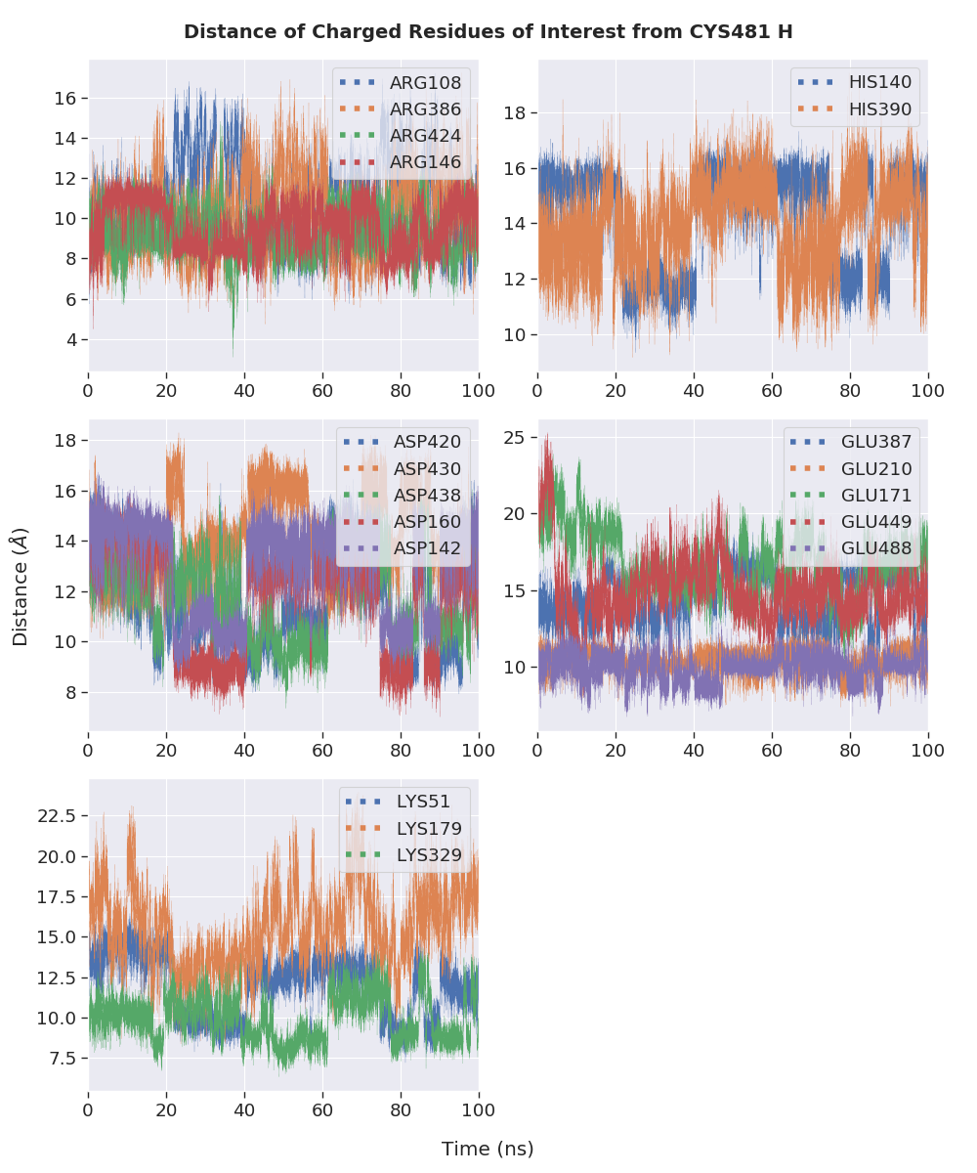

(a)

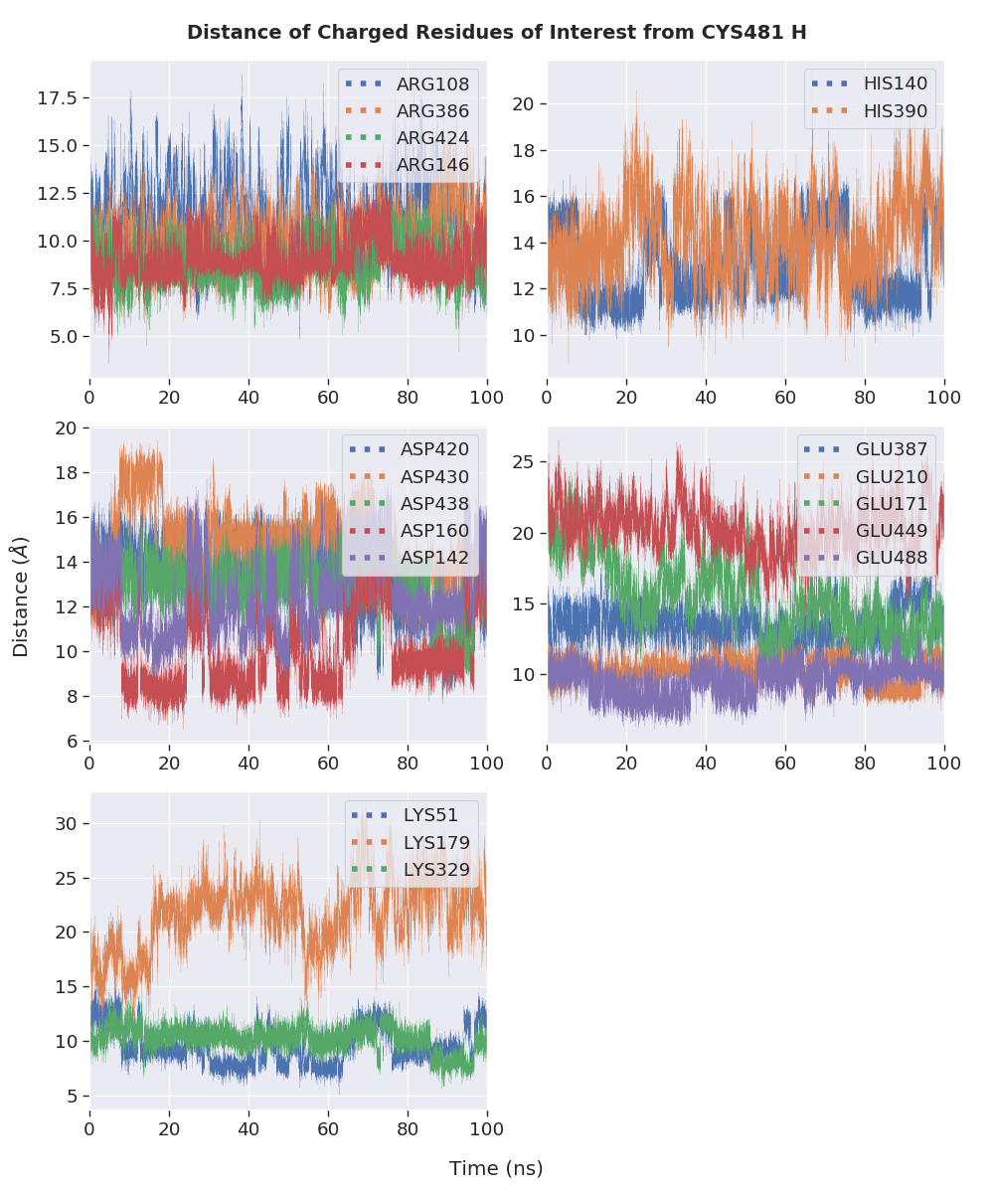

(b)

**Figure S10.** Distance between charged residues of interest and the thiol proton of the unreacted Cys481 of the noncovalently bound BTK containing inhibitors **3** in replicates (a) 1 and (2) 2.

#### Potential Base for Thiol Eliminations

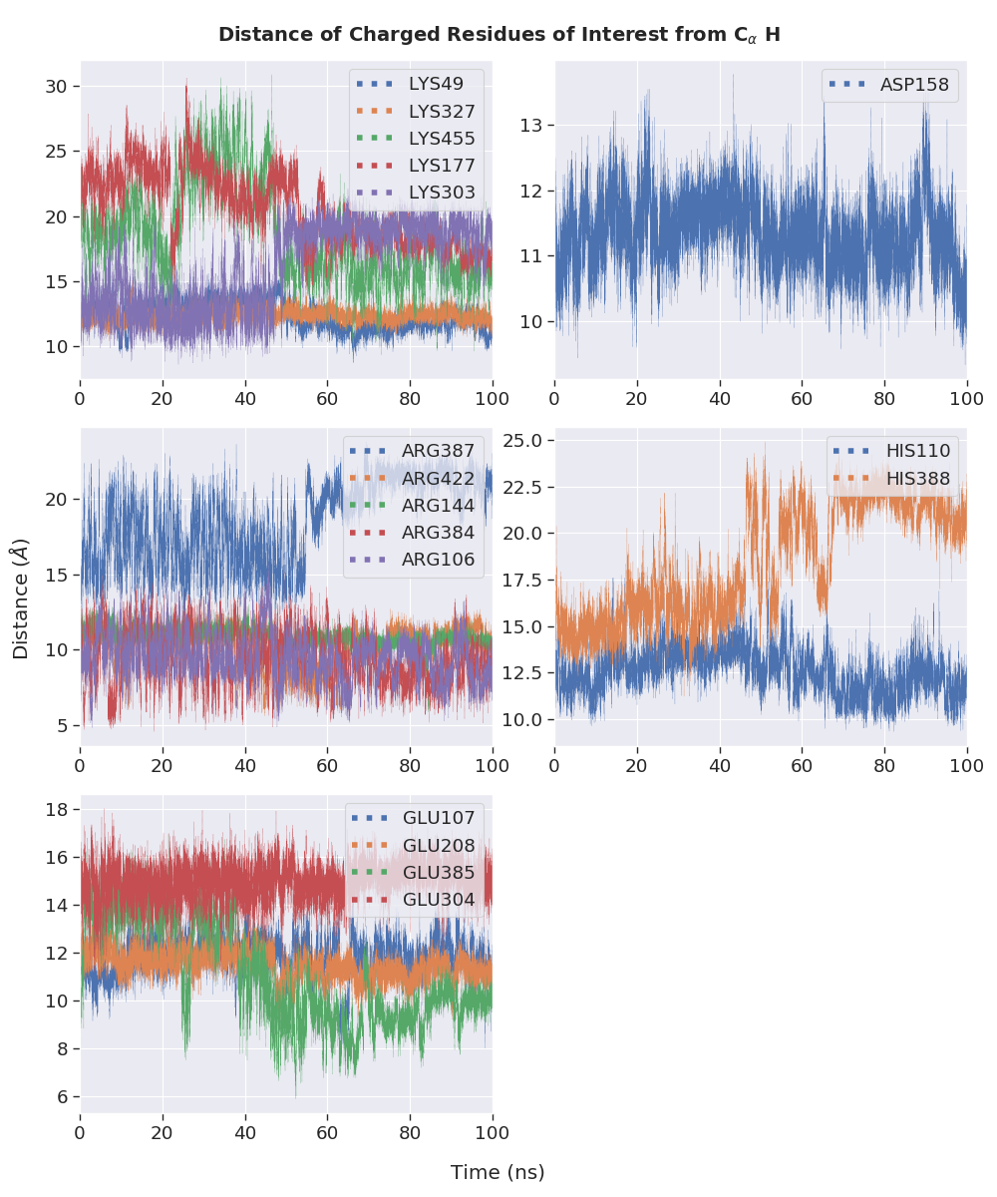

(a)

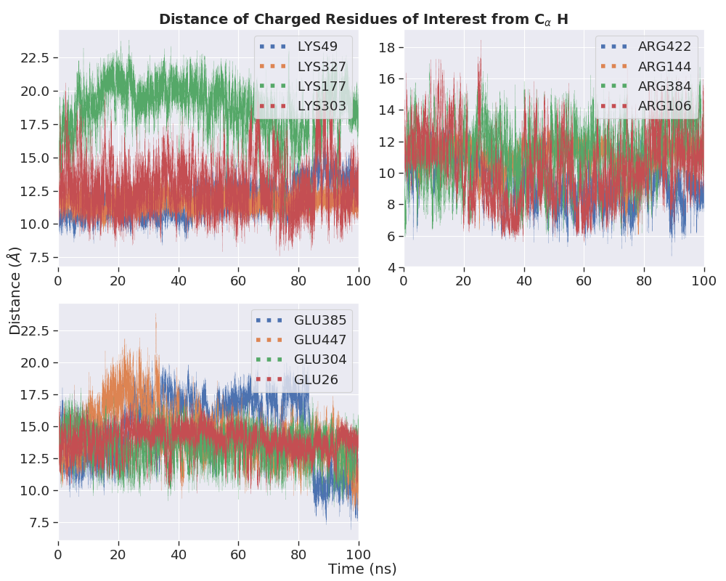

(b)

**Figure S9.** Distance between charged residues of interest and the C $α$ proton of the covalently bound (a) **1** and (b) **3**.

### Energy Barriers for Different Thiol Elimination Mechanisms

Chart 3.1. Activation Barriers for Different Thiol Elimination Mechanisms

